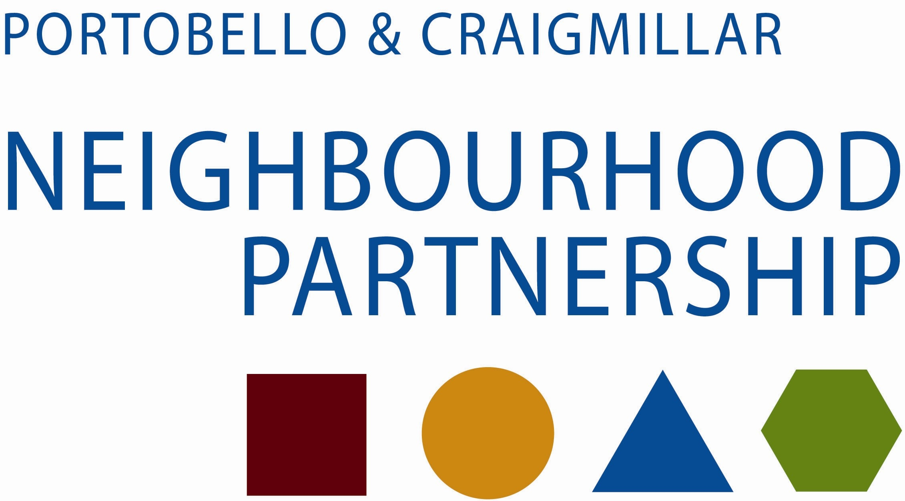

Business & Agenda Planning Meeting

29 April 2014, at 10.00 am,
East Neighbourhood Centre, 101 Niddrie Mains Road

Agenda

- Apologies

- Action Note from NP Meeting of 26 February 2014

- Edinburgh Local Development Plan Ben Foster, Planning

- Edinburgh People’s Survey David Porteous

- Community Grants Applications report to follow

- Local Community Plan 2014-17 update

- Agenda Planning Proposals – P&C NP Meeting, 28 May 2014, at 6.30pm, in the East Neighbourhood Centre, 101 Niddrie Mains Road
Possible agenda items –
- Action Note of last meeting
- Youth Gathering- report from Presenting Young People
- School – progress reports Karen Prophet to attend from C&F
- East Children’s Services Management Group – Nancy Henderson and Jim Hunter
- Community Grants Fund
- Sub group notes
- Date of next meetings –
10 September 2014
19 November 2014
11 February 2015
13 May 2015

- AOCB

Thank you for taking the time to attend

