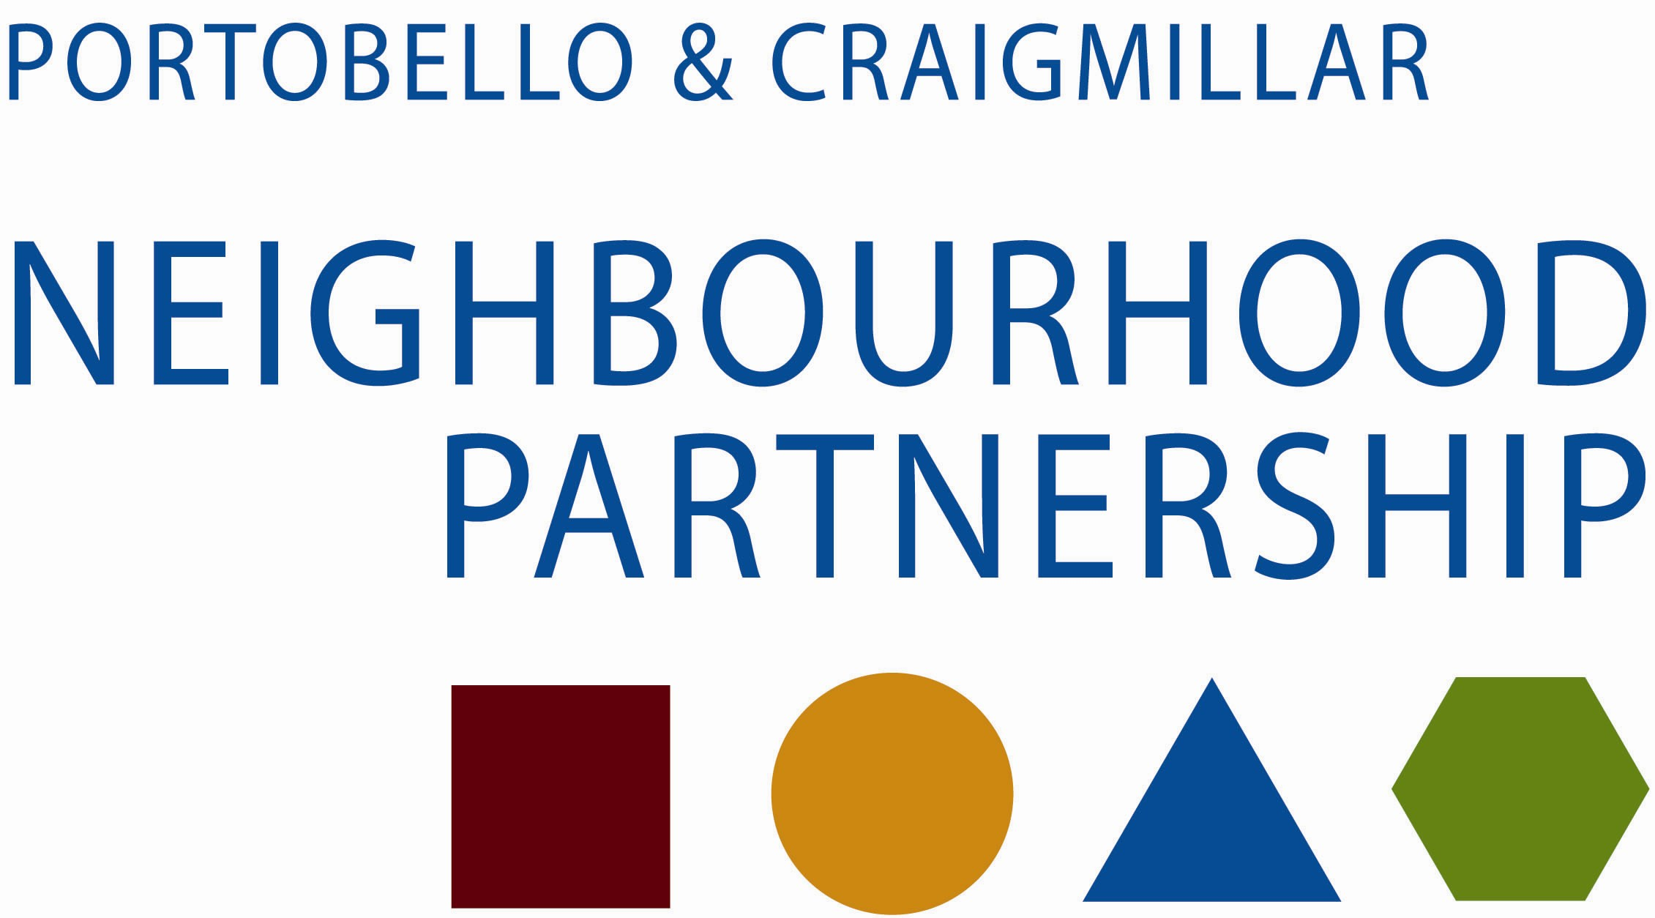

Community Safety sub group

Wednesday 12 March 2014 at 2.00 pm in Newcraighall Fire Station.

Present

Cllr Mike Bridgman Chair
Cllr Maureen Child
John Young Police Scotland
Andy Girrity Scottish Fire & Rescue Service
Derek McGowan Community Safety, East Team
Robert Todd Aspect Resident/Owners Committee
Margaret Grieger CCRG
Helen Horn Aberlour Outreach
Susan Carr Neighbourhood Alliance
Nikki Stenhouse Link Housing Association
Emma Kyles Cafe K
Graham Rowan SfC PDO

1. Apologies
Roddy Hardy Police Scotland
Sarah Halliday Dunedin Canmore
Martin Macaulay SfC East Programme Manager
Terry Tweed Craigmillar Community Council

Item | The Chair thanked Andy for hosting the meeting. | Action
2 | Minute of 22 January 2014  Agreed
3 | Matters Arising
4 | Action Plan –Updates
a. Council
- Derek referred to the Community Safety report for 21 January to 10 March, previously circulated, highlighting that the main issues continue to be nuisance and domestic noise. Cases lodged with the legal team were ongoing
- The most complaints to Environmental Wardens concerned dog-fouling and fly-tipping. The use of the stencils has been widely welcomed throughout the city and has been seen to have had a significant effect. There have been more Fixed Penalty Notices, issued, and he advised that there would be an increase in these fines, up to £80 for littering an £200 for fly-tipping. These would be accompanied by a publicity campaign from the Scottish Government.
- Derek reported that there is a case with the Procurator Fiscal over fly-tipping in Greendykes; the scale of this may lead to a bigger fine and costs incurred by the Council being sought.
- Susan pointed out that recent tipping in Greendykes had been on the road, and a crash had been narrowly avoided. She asked if the wardens could check on this regularly.
- Maureen asked if there was evidence that FPNs for dog-fouling prevented dog-owners from repeating the offence. Derek advised that until recently records of people accepting a FPN were not kept, and it was difficult to quantify. However local wardens would often know if the offender had been caught before and could recommend prosecution rather than a FPN.
- Susan advised that the Area Board was recommending replacing the CCTV camera in Bingham: she had heard that there were claims that this would be targeted and destroyed too. She asked if there was an option of siting the new one elsewhere, or providing greater protection for it. Mike pointed out that that site had been carefully chosen because if its coverage. Derek reported that the cost of infrastructure works was very high, 3-4 times the cost of a camera, Consideration would be given to using a mobile camera to help cover it.

b. Fire & Rescue Service
- Andy had circulated a report detailing the activities of the Fire and Rescue Service, outlining the high level of Home Safety Visits and the national campaigns. He commented on the transition to the national service, which had seen few changes at a station level. Some improvements were already evident, and there had been some teething problems
- Mike referred to the Common Star Aware campaign, with particular reference to the Portobello incidents.

c. Community
- Emma had circulated a report, and highlighted that the Children’s Group were co-ordinating its activities with the Fire Service calendar of events Andy had supplied at the last meeting. Detached youth work in Portobello had identified a core group of youngsters to work with.
- The Saturday night pilot had been the most successful pilot that Cafe K had run, and she was delighted that Castle Rock, Link and Dunedin Canmore had been able to provide an extension to the funding.
- The success of the MVP group, the only one in Scotland not based in a school, was also highlighted.
- Susan highlighted the Community Council’s concern over the recent accident in Newcraighall. There was a concern that contractors no longer consulted with the local community on safe routes to and from their developments. There was more general concern at the reduction in attendance by the police at community meetings, which she felt jeopardised good relations which had been built up. Maureen felt that this regrettable incident had happened because a driver had not followed the proper rules, and that generally contractors followed the correct procedures.

d. RSLs
- Nikki highlighted the Saturday Service funding which the 3 Housing Associations had picked up following the previous meeting.
- Nikki reported Housing Officers had attended the Community Policing Teams’ training sessions, and reinforced the strong partnership working between the Police, landlords and the community.

e. Police
- John explained the Police report which had been circulated. He outlined the balance between Community and Response Policing, and the priorities within the Police Service.
- Again, Portobello & Craigmillar is generally a peaceful area with low levels of crime. Assault and violence is generally low, the exception being domestic violence where there have been around 130 reports. This high number is partly due to more people reporting incidents, GIRFEC and other issues. This is a key policing priority. Derek advised that there were fortnightly domestic abuse TAC meetings, with Women’s Aid in attendance. He recommended that the Council’s Domestic Abuse Lead Officer be invited to the next meeting – this was agreed.
5 | Note to Neighbourhood Partnership
 | The group would meet again before the next Neighbourhood Partnership and would decide on its note then.
6 | AOCB - none
7 | Next meeting: Wednesday 30 April at 2.00 pm at East Neighbourhood Centre, 101 Niddrie Mains Road.

