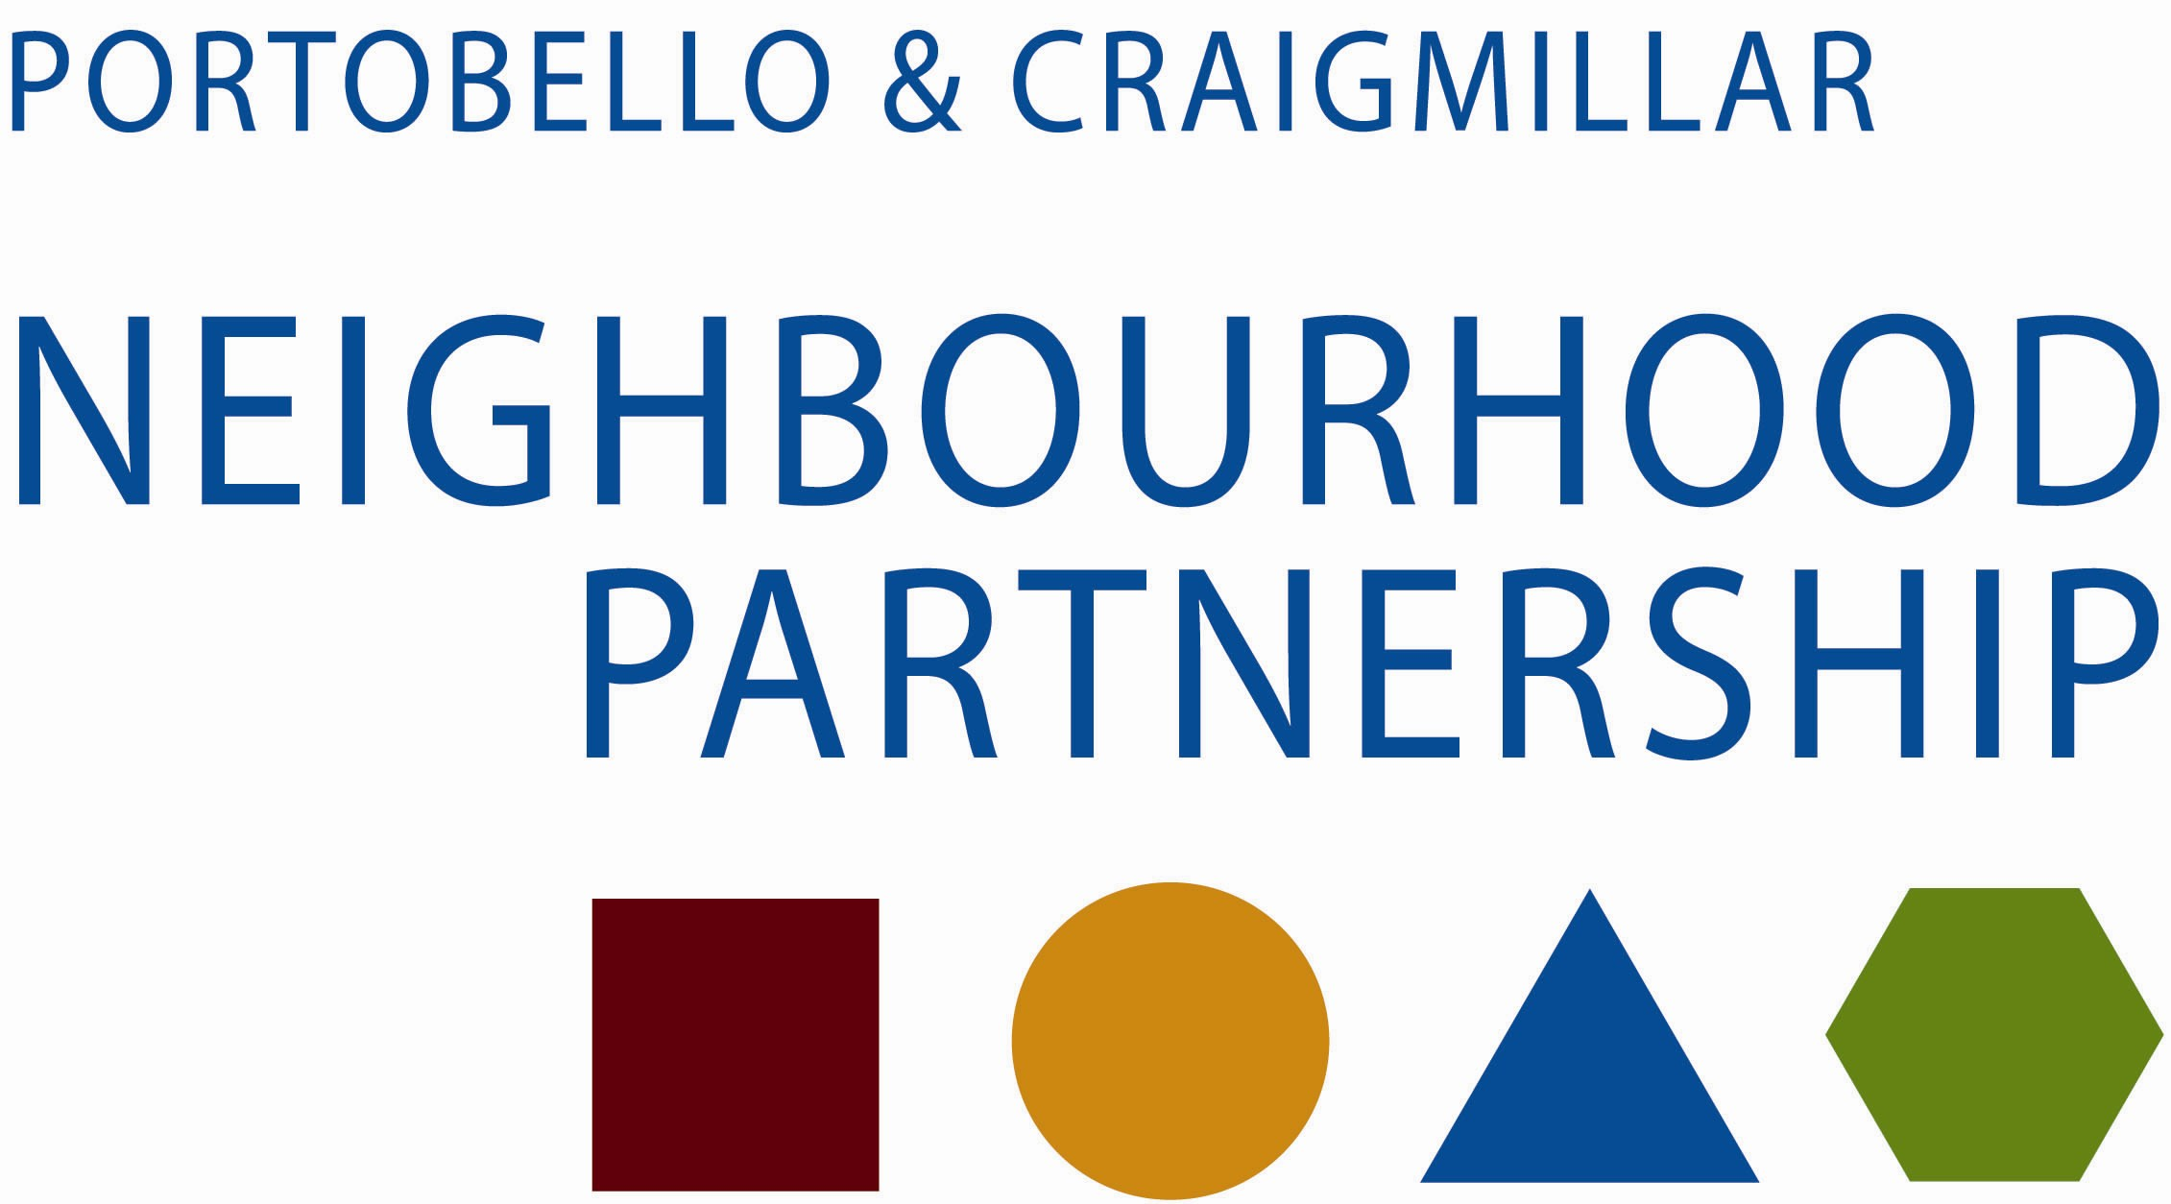

Community Safety Sub Group

Wednesday 30 April 2014 at 2.00

In the East Neighbourhood Centre, 101 Niddrie Mains Road

Agenda

- Apologies

- Minute of meeting of 12 March 2014

- Matters arising

- Action Plan – Updates

  - Council
  - Fire
  - Community
  - RSLs
  - Police

- Note to Neighbourhood Partnership

- AOCB

- Date of next meeting

Thank you for taking the time to attend

