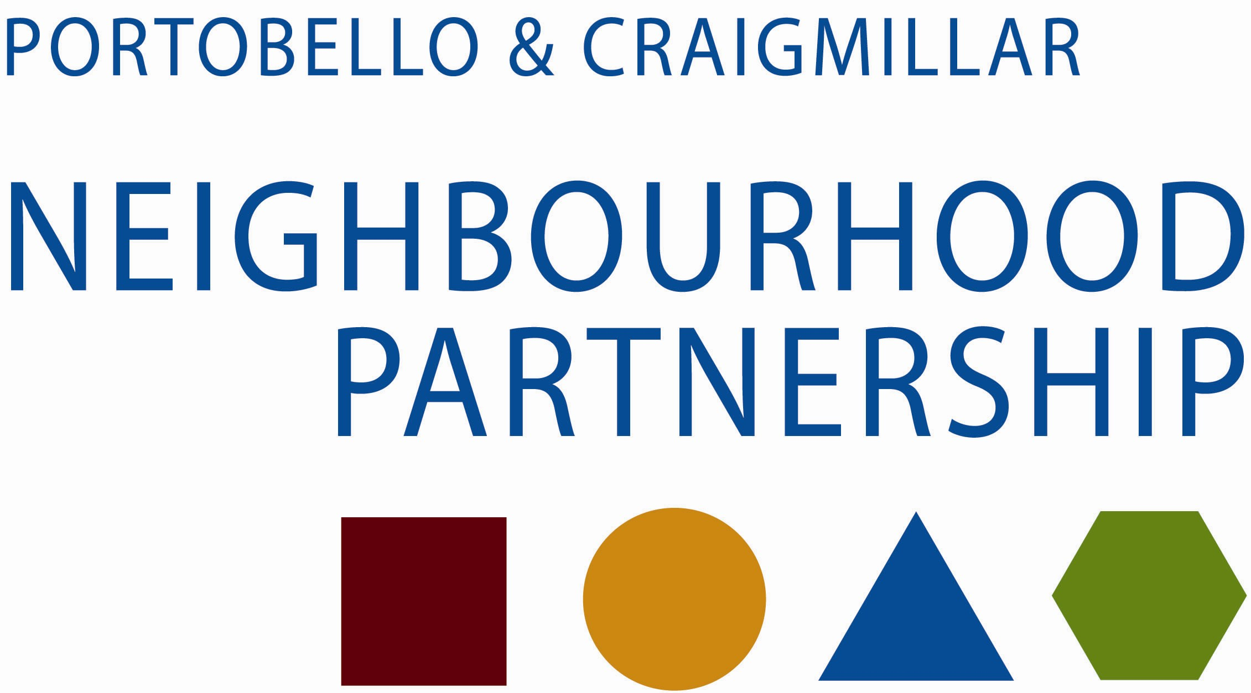

Housing and Regeneration Sub Group

4 June 2014

10.30 am in the East Neighbourhood Centre

AGENDA

- Apologies

- Minute of meeting of 23 April 2014

- Matters arising

- Action Plan
  - Housing Service
  - RSL update
  - Planning update
  - Development update
  - PARC update

- New Local Issues

- Note to Neighbourhood Partnership

- Future Agenda Items

- AOCB

- Date of next meeting

Thank you for taking the time to attend

