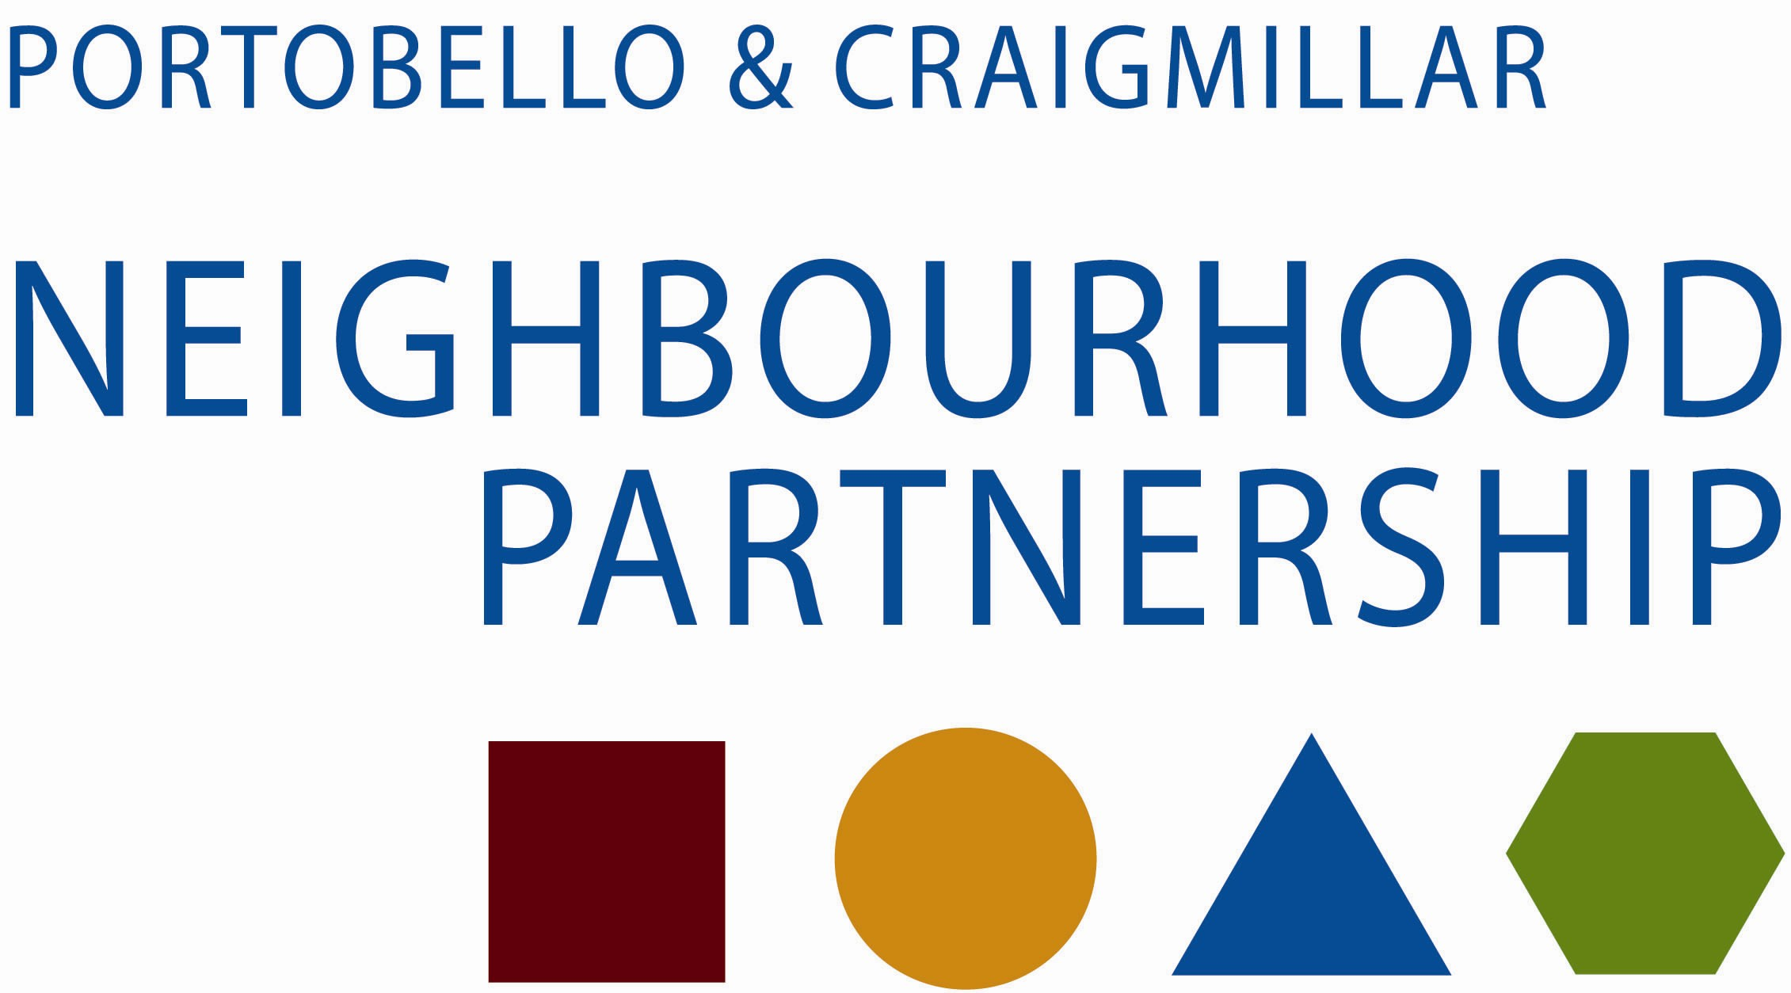

Economic Development and Employment Sub-Group

Wednesday 14 May 2014 at 2.00 pm
in Cre8te, Castlebrae Business Centre

Agenda

- Apologies

- Note of meeting of 11 March 2014

- Matters Arising

- Employment Access
- Liam Smith, Recruitment and Skills Centre, Fort Kinnaird
  - Local partner feedback

- Economic Development –Infrastructure
- BioQuarter report
- PARC Update

- Business Development
  - Incubator
  - Social Enterprise

- New local issues

- Note to Neighbourhood Partnership

- Date of next meeting -

Thank you for taking the time to attend

