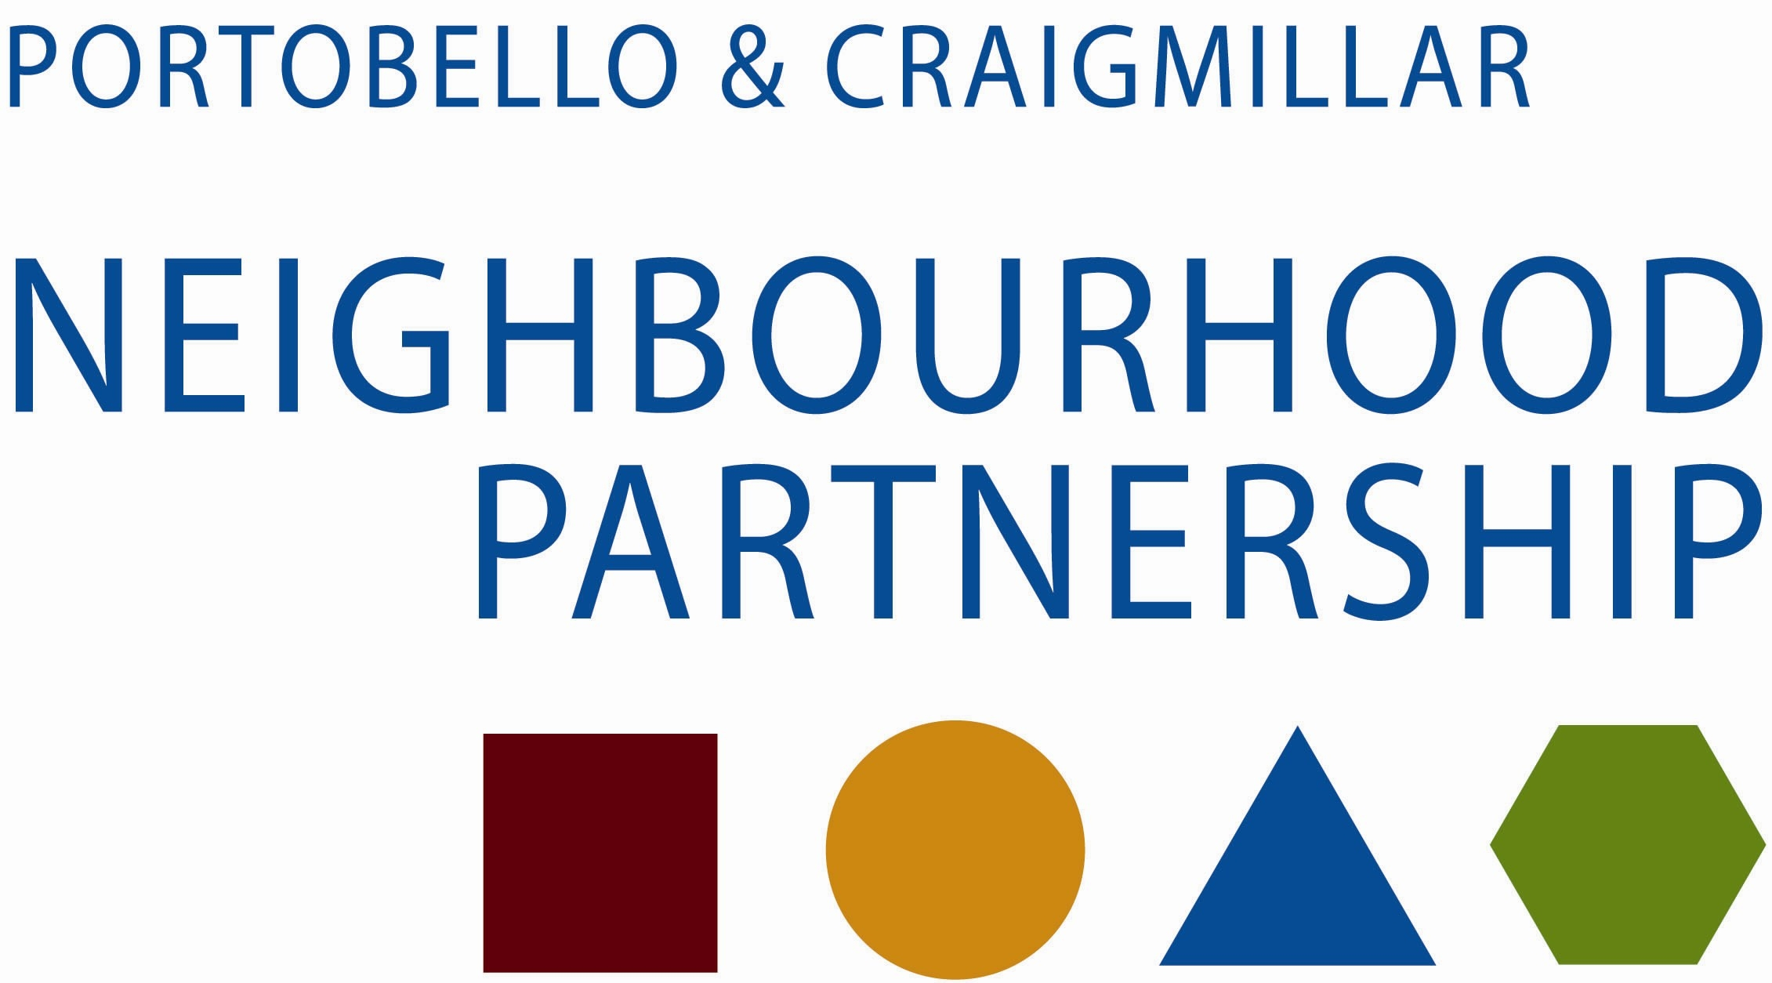

Business Meeting

24 June 2014, at 10.30 am,
East Neighbourhood Centre, 101 Niddrie Mains Road

Agenda

- Apologies

- Local Community Plan 2014-17

- Participatory Budgeting

- Community Grants Applications

- AOCB

Thank you for taking the time to attend

