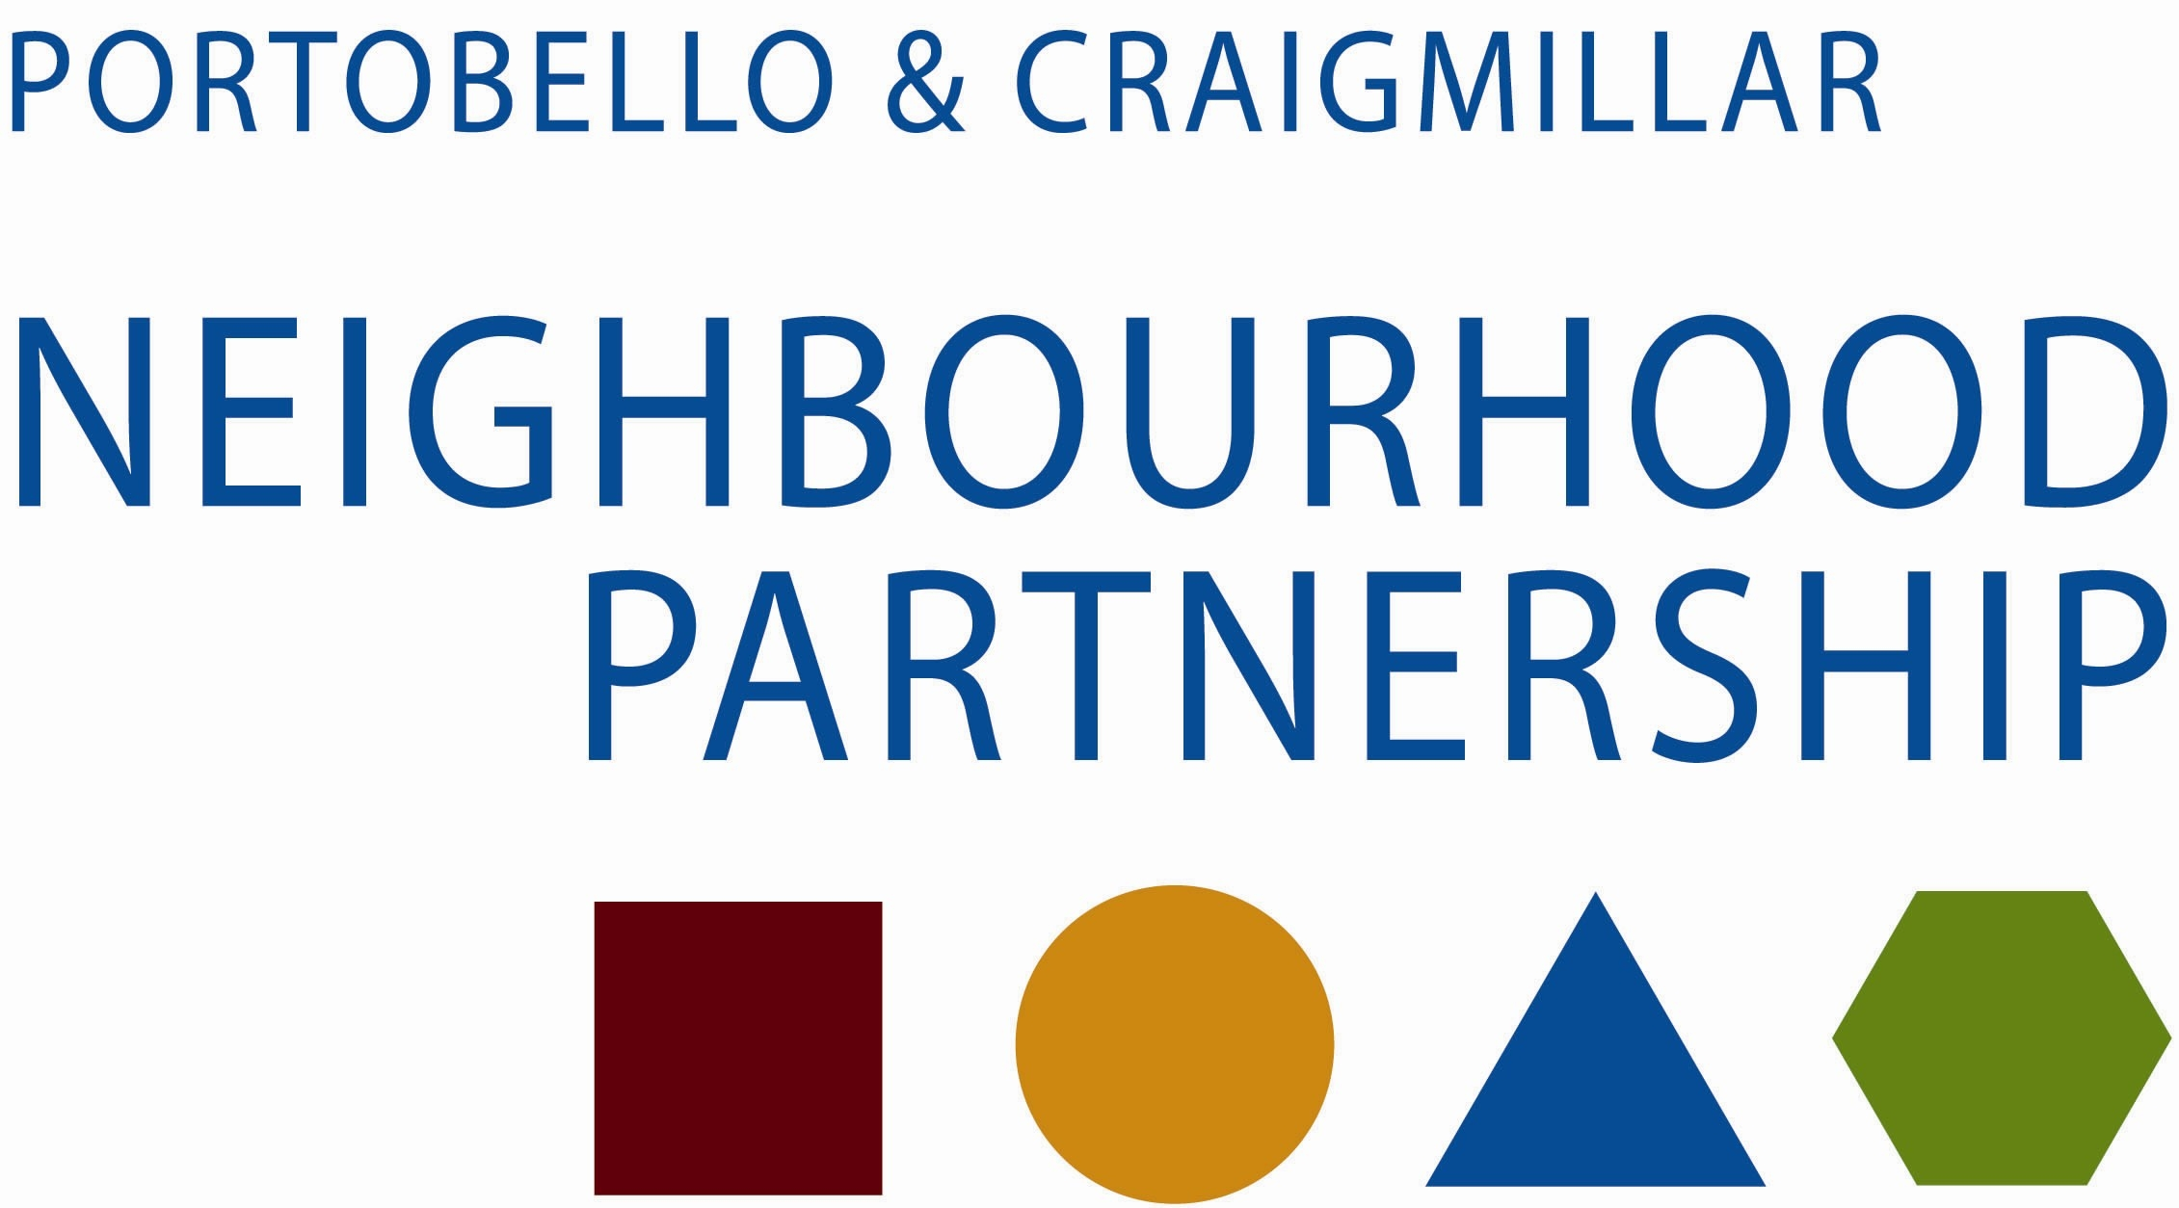 May 2014

NP OPTIONS PAPER – PARTICIPATORY BUDGETING (PB)

Following a request from the last P&C NP Business Meeting on how best to utilise/ allocate Community Grants Fund, this paper provides options re: Participatory Budgeting for consideration.

Initial research indicates that the use of the PB approach did increase local engagement and participation. An original top slice from the CGF paid for the first Leith Decides event, but services are now expected to meet the costs. To support the Leith model, commitment by staff, partners and NP was supplemented by the delivery of basic training on the processes/principles involved.

If the NP wishes to move forward, Lorraine Duckworth has offered to provide assistance/training on the basics as required. It is suggested that a workshop for NP, other partners and staff would be arranged to cover basic principles/processes.

To facilitate a final decision on how best to move forward, the NP is asked to consider/agree the following questions/demands and options.

Basic considerations:
- To begin in September 2014 will require a very quick NP decision re: future / current submissions of CGF applications/or a decision to retain all remaining budget for allocation in September using a new PB approach? This may conflict the recently implemented criteria changes applied by the NP for this year’s budget. It may also leave little time to effectively advise the community that things are changing.
- Leith – No minimum/maximum bid – would this be the preferred option?
- Timeline – Advice received is a minimum 3 month ‘lead-in’ is required to allow publicity/submissions etc. The process has been reported as time-consuming and therefore a proposed start date of September may not be feasible, combined with ongoing work demands related to the refreshed LCPs.
- Costs - Leith estimates (using free venues) that the biggest cost is printing and publicity approximately £1600 PA.
- It should be noted that they do not supply any refreshments due to the high number of attendees. Events are held in a venue with access to cafe. CLD pay for janitorial/toilet attendant and provide activities e.g. face painting on the night for children. If P&C events were held in ENC, library staff (with some additional staff support) may be able to assist, and negotiating opening the cafe for the event(s) may be possible.
- Support for local groups/other will be required to effectively deliver a PB approach. In Leith a CLD worker supports the process, including working with groups on constitution/bank accounts etc. Would/could this be replicated in this area?

- All events are set up in a market stall style.
- It has been reported that PB demands a major commitment from the NP Board and support staff, including counting etc, done on the night. The voting process involves all attendees scoring all projects out of 5 – Any missed scoring makes a voting slip ‘null & void’
- Pre-scoring (on the same basis and kept confidential) via a poster campaign in libraries is possible in advance of the main event – However, this has impacted on numbers attending the event
- The PB Development Group are looking at other PB opportunities and how best to promote the process.
- Should the NP consider if any other/part NP budgets be included e.g. NIP/NEP. The current NP Environment Forum bus tour is already one form of a smaller scale PB process?

Recommendations:

The NP Business Meeting is asked to consider and agree one of the following options:
- The feasibility of a September PB event; or
- A ‘strategic NP development decision’ for the implementation of a PB approach at the start of the next financial year i.e. April 2015 (first event April 2015); and
- Decision to include % of total CGF to be allocated via PB, and the NP’s commitment to support the effective delivery and early notification for community groups etc about changes to CGF allocations; or
- To retain the current process - pending outcomes from the PB Development Group.

If the decision is to move forward with PB – NP to:

- Commit to a workshop for NP and partners - to support joint planning/delivery
- To seek assurances/identification re: support from partners/services to deliver the new process
- To consider if other budgets/part budgets Could/should be included in the new process?
- To consider facilitating further discussion on ‘other opportunities’ e.g. could a ‘few service delivery choices’ rather than ‘money’ be included in the ‘extended local decision making process’ (or as part of future NP budget consultation)?
- To agree to promote/publicise the new approach as ‘a local priority’ - aimed at increasing local democracy/governance and participation and a key element in the updated NP LCP.

Contact
Mary Dunbar
East Partnership & Information Manager
529 4415
0788 150 1304

