

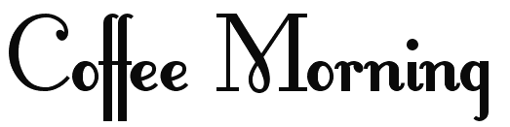
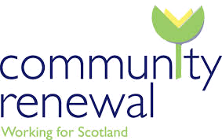
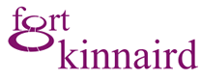

-Community Renewal-
Friday 3rd
October
2014
10am – 12pm
3 Hay Avenue
Craigmillar
FREE
Tea and
Coffee

You are invited to join our coffee morning on Friday 3rd October 2014. You do not need to be registered, just pop in and see us. There will be a free tea or coffee and our job advisors will be available to give information about our services and 100’s of job opportunities at Fort Kinnaird Retail Park.
FREE
Advice and
Information
100’s
of Job
Opportunities
At Fort
Kinnaird
Meet
Our Friendly
Staff
0131 629 9858
3 Hay Avenue, Craigmillar, Edinburgh

