0131 629 9858

3 Hay Avenue, Craigmillar, Edinburgh



**Meet**

**Our Friendly Staff**

**100’s**

**of Job**

**Opportunities**

**At Fort**

**Kinnaird**

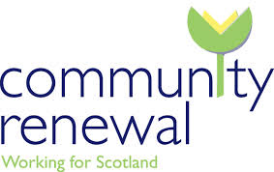

**FREE**

**Advice and**

**Information**

You are invited to join our **coffee morning** on **Friday 3rd October 2014.** You do not need to be registered, just pop in and see us. There will be a **free tea or coffee** and our job advisors will be available to give information about our services and **100’s of job opportunities** at **Fort Kinnaird Retail Park**.

**FREE**

**Tea and**

**Coffee**

**Friday 3rd October**

**2014**

**10am – 12pm**

**3 Hay Avenue**

**Craigmillar**

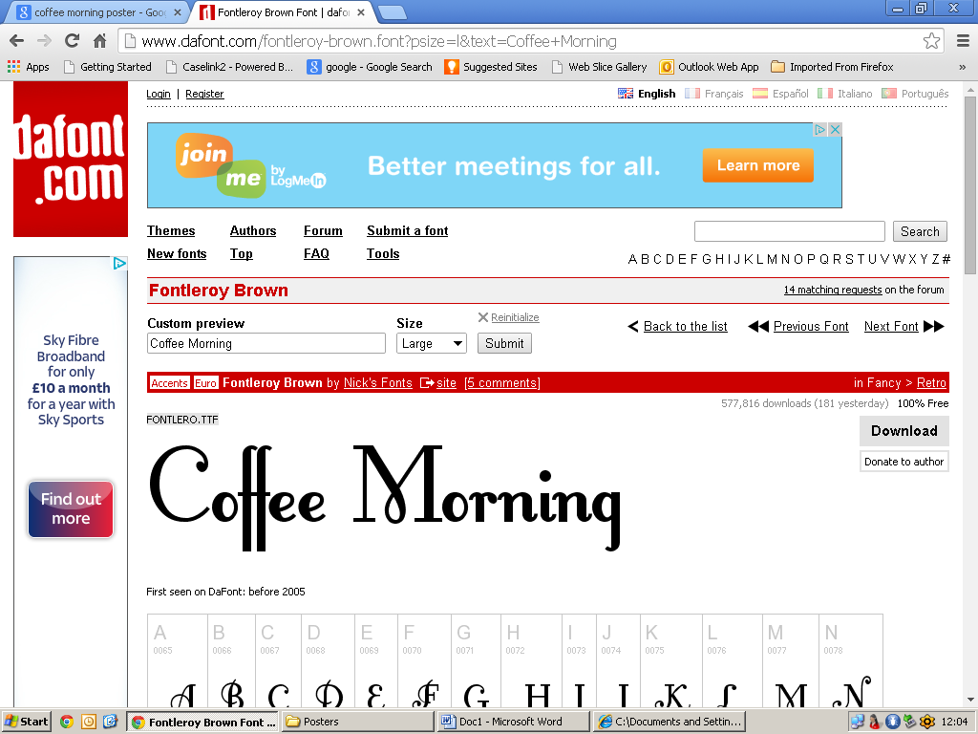

**Friday 3rd October**

**2014**

**10am – 12pm**

**3 Hay Avenue**

**Craigmillar**

**FREE**

**Tea and**

**Coffee**

You are invited to join our **coffee morning** on **Friday 3rd October 2014.** You do not need to be registered, just pop in and see us. There will be a **free tea or coffee** and our job advisors will be available to give information about our services and **100’s of job opportunities** at **Fort Kinnaird Retail Park**.

**FREE**

**Advice and**

**Information**



**100’s**

**of Job**

**Opportunities**

**At Fort**

**Kinnaird**

**Meet**

**Our Friendly Staff**



0131 629 9858

3 Hay Avenue, Craigmillar, Edinburgh

