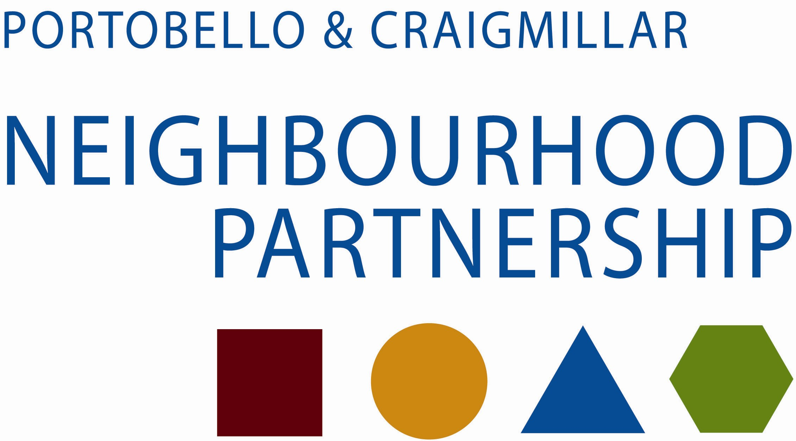

Health & Wellbeing Sub-group

MINUTES OF THE PORTOBELLO & CRAIGMILLAR HEALTH & WELLBEING SUB-GROUP MEETING HELD ON TUESDAY 9TH SEPTEMBER 2014 IN THE HAYS BUSINESS CENTRE, HAYS AVENUE, EDINBURGH

PRESENT

Carl Bickler (Chair) Edinburgh Community Health & Social Care Partnership
John Palmer - Edinburgh CHP
Sabina McDonald - NHS Lothian Health Promotion
Anne Crandles - Headroom, ECHP
Tommy George - Edinburgh Leisure
Claire Pattullo - Community Renewal
Helena Richards - Carr Gomm Community Compas
Julia Flockhart - Health-in-Mind
Susan Carr - Neighbourhood Alliance
Evelyn Forbes - Cyrenians
Steve Mayes - Health-in-Mind
Nick Woodhead - Volunteer Centre Edinburgh
Pat MacKinnon - Thistle Foundation
Mark Hoolahan - Thistle Foundation
C. Mantle - Edinburgh Community Food

- APOLOGIES

Karin Chipulina - Carr-Gomm
Graham Rowan - East Neighbourhood Team
Cllr Maureen Child - CEC
Liz Wilson - Community Learning & Development
Anne Dignan - Resident
Jane Milne - East Neighbourhood Team
Lesley Reid - NHS Lothian Health Promotion
David White - Assistant General Manager ECHP
Heather Yang - Volunteer Centre Edinburgh
Midge Lamb - Caring-in-Craigmillar
Fraser Wood - Community Renewal
Alison Milne - Keep Well -

2. Minutes of Meeting Held on 1st July 2014
Agreed as accurate record
3. Matters Arising & Updates
3.1 Wrap-Around Services – A Systematic Review
Lesley Reid was unfortunately unable to attend the meeting to offer a more comprehensive update in this area. There is however a strategic approach working in Craigmillar, of signing, linking and ‘case managing’ people with increasingly complex issues. It is now necessary to collate and review the spectrum of resources and literature about these ways of working. This appears to be on track with NHS Health Management Library now willing to take this on. There is a need for a central, authoritative review of service redesign that is focused on the patients’ journey and experience, and to embed this new way of working in the 3rd and statutory sectors by delivering an evidence base that this in fact an effective way of working.
3.2 Craigmillar Counselling Service – DNA Rates
Steve Mayes introduced himself to the group and will now assume the counselling representative role following Eileen Johnston’s departure.
DNAs have an enormous impact on the healthcare system in terms of cost and waiting time, significantly adding to delays along the patient pathway and patient dissatisfaction, with the current rate fluctuating around 25-30%. Reducing the number of patient non attendances will create improved service and productivity, with evidence suggesting that a greater understanding of DNA rates is required to aid the improvement of them.
It was recognised in discussion that the label of a mental illness in itself can cause stigma and problems. The lack of awareness and information and the stigma attached to the word “mentally ill” can reinforce the stereotypes that people have about it. Gaining more awareness about mental health issues and illnesses can dramatically reduce the overwhelming effect of this word on people and would enable them to have a better understanding and acceptance of their mental health difficulties or those of the people around them. With such a complex issue, the Group discussed various avenues that could be utilised which included evening appointments, working from alternative venues, shorter appointments or initial engagement techniques such as texting or phone calls. Community Renewal has carried out considerable work in this area and will share the results of their current telephone engagement work for bowel screening.
Steve will formulate a brief on the discussion, circulate this and build an action plan based around feedback and ideas from the Group.
4. Health Inequalities
4.1 Young People and Mental Health Services
Unfortunately Jane Milne was unable to attend the meeting but continues her engagement with a group of local young people in conjunction with CL&D. With a Facebook page now developed by the group (PYP – Presenting Young People) and an app in the pipeline, they continue to go from strength to strength and have been involved in various city wide events. One of the current initiatives the Group is focused on is the awareness of mental health and how young people interact with the various health services. Young adults’ barriers to care reflect limitations in their knowledge of mental health problems and available treatments, but possibly also a failure of existing mental health services to engage young people. Unless services are designed in a way which young people actually want to engage and identify with them, they will not be successful. This will also mean a much greater emphasis on the support that is provided in non-mental health settings, the places where children and young people work and play, in primary care, and on enhancing family and peer support. The information that accompanies these also needs to be correct and factual.
The group recognised that schools have an important role to play in protecting and promoting mental health. A stronger focus on emotional health would act as a preventative source for young people and receiving help from a school-base rather than an external counselling service could be perceived to be less stigmatising. But what is key is to engage with young people and allow them to dictate how services are run so they are effective for them. A day conference on this issue was suggested and with this in mind, the group will approach local schools and resource what young adolescents actually want and what they feel is appropriate. Various tools were suggested that could be utilised in conjunction with this including a Scottish mental health first aid course for young people, the befriending service, and mental health awareness week paraphernalia. Feedback on this work will be provided at the next meeting.
4.2 Welfare Reform Guide.

Subsequent to the discussion tabled at the last meeting, a six page guide to a crisis has been produced by Sylvia Baikie and Sabina McDonald. This utilises the template used by Midlothian Council in their crisis guide and is Edinburgh based. The draft was circulated during the meeting and the group were able to feedback initial ideas and suggestions which will aid the review of the document. It was thought there should be a section on local resources. Any further comments or suggestions would be welcomed by the team.

5. Total Place – East Neighbourhood
5.1 GPs Headroom Project

This is a Scottish Government funded programme with an aim to improve health outcomes significantly for people in areas with concentrated economic disadvantage. The initial stage is to allow GPs funded time out of their working day, i.e. “headroom” to find new ways of working with a diverse range of partners and agencies. This is by no means being done in isolation with work throughout Scotland and developing links with NHS Grampian, Fife and the Highlands. Phase one of year one funding has now been secured and the clinical leads for the east were announced as Dr Jane Marshall and Dr Alex Connan. Their first key priority will be to orchestrate a House of Care event which will see each practice identify a key issue to focus on and then invite other service providers to attend their table at the event.

The South west will take a slightly different approach and orchestrate an event under the umbrella of mental health where each practice will take the lead on a different strand of this particular topic. They will incorporate the work that is underway in Wester Hailes and also utilise the Nuka model of health and care services in Alaska which has been created, managed and owned by the Alaska Native people. Their approach has been designed to achieve physical, mental, emotional and spiritual wellness, and is about communities and professionals working together to achieve positive outcomes for people.

An event for everyone is planned for later in the year and more details will follow as they become available.

5.2 Photography Project
Lesley Reid was unfortunately unable to attend the meeting and consequently no update was available on this particular project
6. Social Capital – Service Updates and Information
6.1 Edinburgh Leisure – More Families, More Active

A detailed plan was circulated at the meeting and is available on request.

Edinburgh Leisure delivers targeted intervention programmes that seek to improve people’s health and wellbeing, to improve the lives of individuals and communities and reduce the demands on public services. It utilizes sport and physical activity as a tool for addressing some of the challenges to health and wellbeing that arise from living in areas of deprivation. The particular project discussed focuses on the South East of Edinburgh and in particular Craigmillar, and has been developing for 12 months. After consultation with 61 families in the Craigmillar area through the utilisation of 6 focus groups over 3 sites, a project model was developed and a funding application was submitted to Aberdeen Asset Management. The model focuses on young families living on low incomes, increasing the range of activities for the under 5s whilst offering a low cost “why wait” gym session for the parents.

Unfortunately the funding for this project was unsuccessful and with limited internal capacity, there is a desire to pilot certain threads of this project so as not to let the work done on the engagement with the families fall away. There was a suggestion that the White House could be utilised as it is a building that is already attracting young mums and funding applications will continue to be submitted with the group being informed of any further developments.

6.3 My Assets and Personal Strengths (MAPS) – Health – In – Mind
Health-in-Mind is a person centred organisation that promotes positive mental health and wellbeing in Scotland. They have a dedicated team of professional support staff and committed volunteers who work together to produce a broad and unique mix of individual and group support. Operating across Edinburgh and the Lothians and in the Borders, they also run a Scotland-wide counselling telephone line and are currently introducing a new initiative called M.A.P.S
They recognise that people using services come with a great deal of knowledge, skills and talents. M.A.P.S. supports people experiencing mental health difficulties to tap into these assets, and the assets of the community in which they live, to better self-manage their wellbeing. Julia and Katie, M.A.P.S Support and Development Workers, will support people in small groups based in their local community to produce a WRAP (Wellness Recovery Action Plan). This is a personal plan which supports people in their recovery and looks at factors which can promote and protect our wellbeing and help when things get difficult. The project is supported by the Self Management IMPACT Fund for Scotland and is funded until March 2016.
Julia distributed leaflets and posters with more details on the service at the meeting but email copies can be made available on request. She will also utilise an opportunity of working with Edinburgh Leisure.

7. Information Exchange
7.1 SE Local Opportunities for Older People
Routes is a new preventative service to be run by Volunteer Centre Edinburgh which aims to maintain the health and wellbeing of more isolated older people by offering easy access to relevant information on local services and activities in a friendly, supportive, and crucially in an encouraging way. The project will be anchored around a centrally run, simple to access, dedicated phone line run by volunteers to provide information and signposting for the fit and able over 65s in the NW and SE quadrants of Edinburgh. As yet this system is yet to launch but the group will be kept abreast of progress, with friends and families having access. It was noted that this service is different from the ongoing Community Connector programmes.
Volunteer Centre Edinburgh – The Volunteer Centre has recently become a city centre based organisation having lost its 4 subsidiary offices, including Craigmillar. They were present at the meeting to raise awareness and develop key links with other 3rd sector organisations. Key to the organisation is how to reach individuals that aren’t part of the referral process or an agency. VCE staff are happy to come out and talk to groups in order to educate. A road show idea was presented by a member of the group but follow-ups were questioned and the logistics of how this would practically work. The Neighbourhood Alliance suggested attending an event they are organising on getting to know your neighbourhood. This is an open evening where you run your own individual table and present your service. Susan will send out invites for this.
8. AOCB
Thistle - A new brochure designed for the Thistle was circulated in the meeting and details a new facility on the site of the Old Tudsbery Centre, adjacent to the Robin Chapel. Attention was drawn to a typo that should say visits per month instead of visitors per month.
Keep Well - Delivery of Keep Well continues as before across Lothian offering health checks to a target group aged 40-64 in areas of greatest deprivation. They also invite individuals in more vulnerable groups from age 35-64 such as gypsy travellers, homeless substance misuse, ethnic minority groups, and individuals with severe and enduring mental health issues. Craigmillar practice Durham road and the new Niddrie practice all engage and deliver Keep Well and we have reengaged with the traveller’s site.
Keep Well also run a Weight management group at the Jack Kane centre (poster with contact details attached) that keep Well eligible people can attend.
Ramblers Medal Routes - With the Glasgow 2014 Commonwealth Games to inspire us to be more active, Ramblers Scotland has designed their Medal Routes project to help people get to know the paths and green spaces in their local areas. Ramblers Scotland Medal Routes are 3 short circular walking routes that start and finish at the same location. These routes are designed to take approximately 15, 30 and 60 minutes. The starting/ finishing point is called a Hub. We try to pick Hubs such as a café, sports centre, library, or health centre – somewhere that you can relax after your walk with a cup of tea or continue to do another activity or hobby. Both Craigmillar and Portobello libraries are Medal Route Hubs – please follow the web-links below to access the routes and maps;
Craigmillar: http://www.ramblers.org.uk/~/media/Files/Scotland%20microsite/MedalRoutes/MRoutes%20jpegs/craigmillar2.jpg
Portobello: http://www.ramblers.org.uk/~/media/Files/Scotland%20microsite/MedalRoutes/MRoutes%20jpegs/Portobello2.jpg
9. Date of Next Meeting: Tuesday 18 November 2014, Meeting Venue is to be Confirmed

