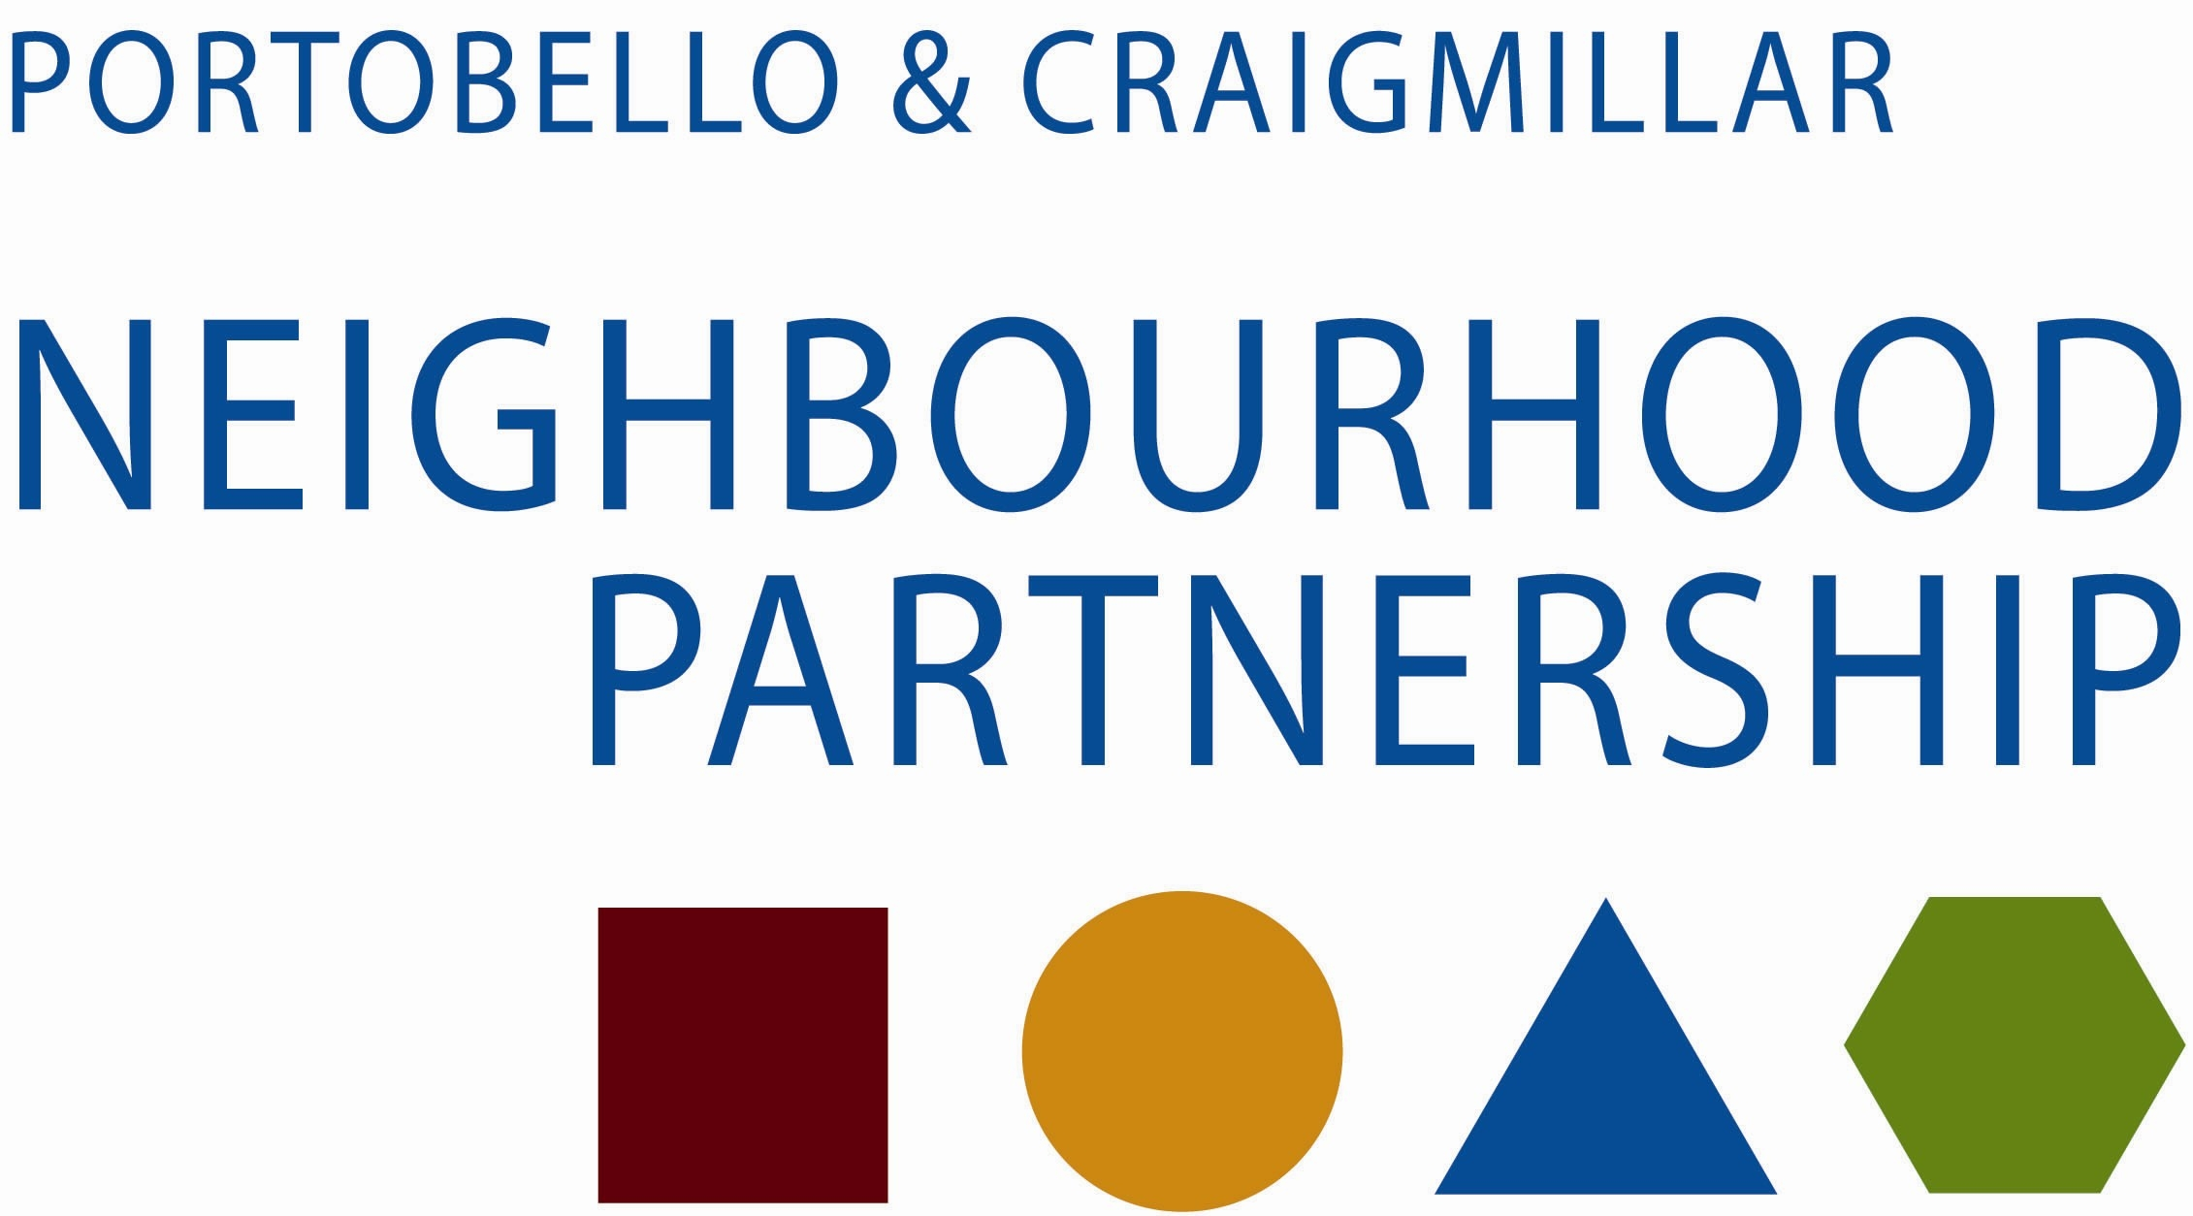

Portobello / Craigmillar Health & Wellbeing Sub-group

A meeting of the Portobello / Craigmillar Health & Wellbeing Sub-group will take place on Tuesday 18 November 2014, 10.30 am – 12.30 pm at Jack Kane Centre Community Wing, Niddrie Mains Road, Edinburgh

Please note new venue

AGENDA

- Apologies (5 min)
- Minutes of meeting held on 9 September 2014 Attached (5 min)
- Matters Arising & Up-dates
  - Young people and mental health services Jane Milne (5 min)
  - Craigmillar Counselling service - DNA rates Steve Mayes (5 min)
  - Edinburgh Leisure - More Families, More Active Tommy George (5 min)
- Health Inequalities
  - Welfare Reform guide Sabina MacDonald (10 min)
  - CEC SforC Mental Health Awareness Group George Norval (10 min)
  - Short-term Housing Support Cyrenians (5 min)
- Total Place – East Neighbourhood
  - GPs Headroom Project Alex Connan (15 min)
  - House of Care Alex Connan (15 min)
- Social Capital - service up-dates and information
  - Veterans Men in Sheds Pat Mackinnon (5 min)
  - Community Growing Event Karin Chipulina (5 min)
- Information Exchange
  - South East Recovery Hub up-date Phillip Heaton (5 min)
  - HOT Substance Misuse Project Nike Oruh (5 min)
  - Parent and Carer Support - attached
- AOCB
- Dates of future meetings - attached

