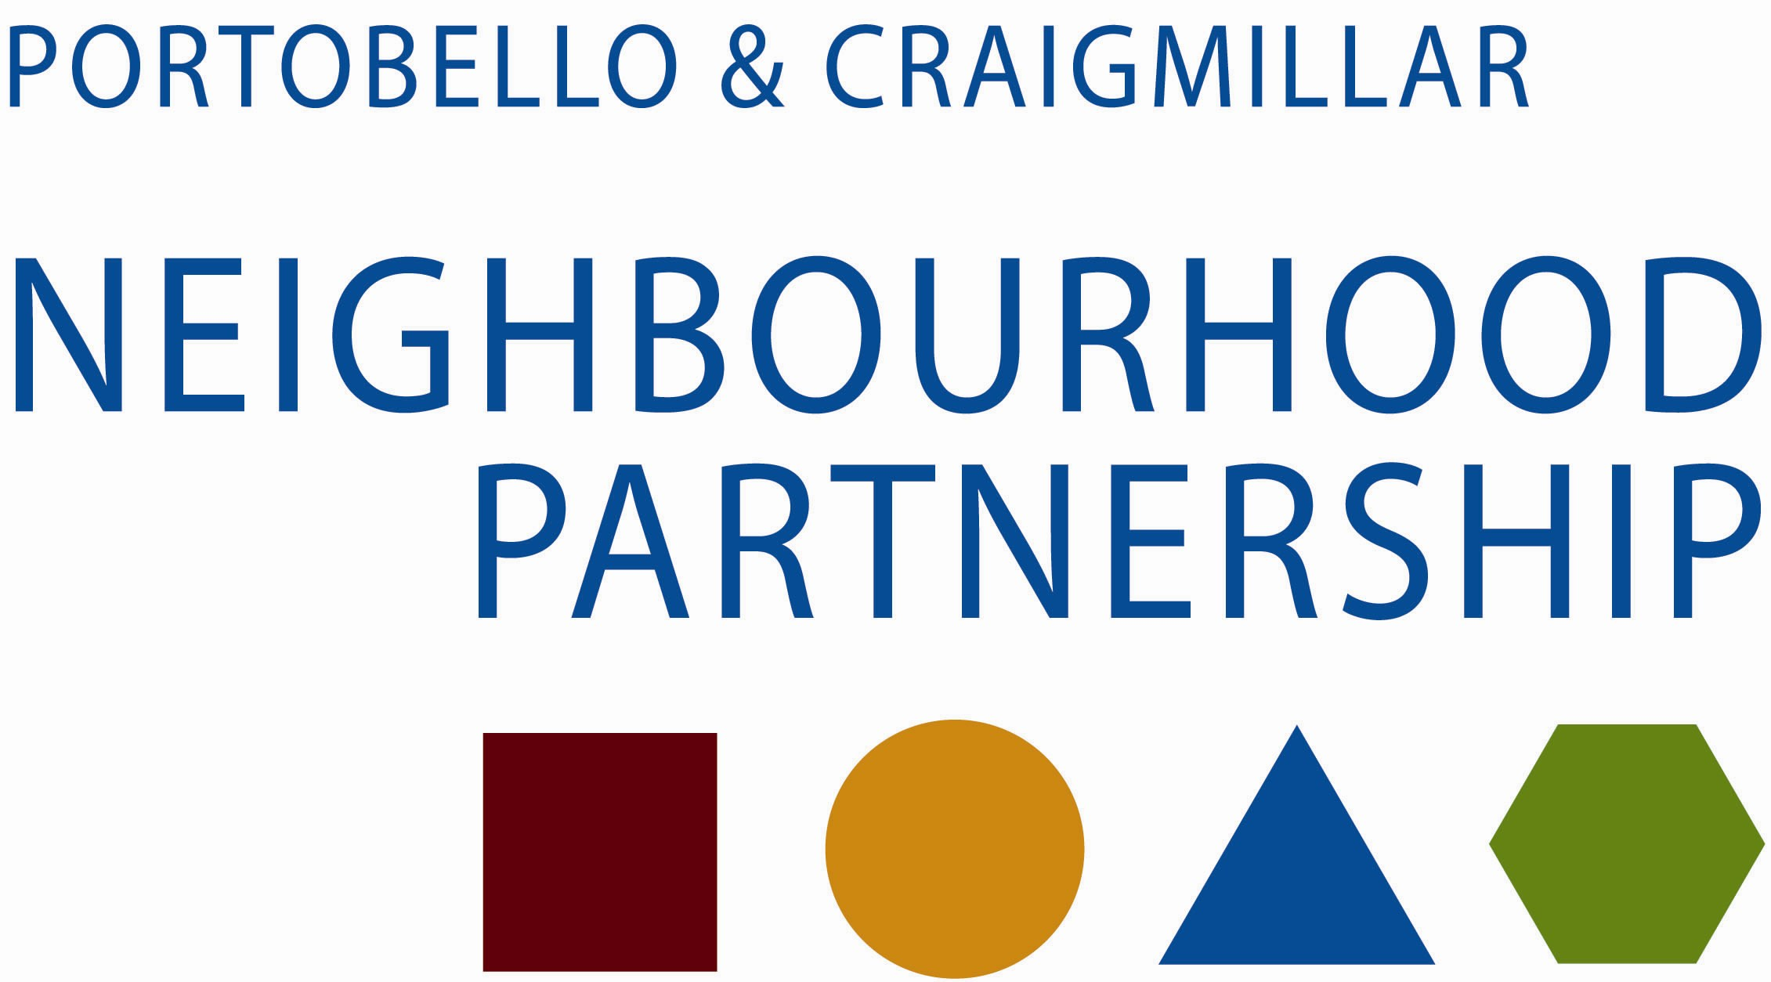

Health and Wellbeing Sub-group: 2015 Proposed Dates

- Tuesday 10 February 2015 10.30 am

- Tuesday 21 April 2015 10.30 am

- Tuesday 23 June 2015 10.30 am

- Tuesday 8 September 2015 10.30 am

- Tuesday 17 November 2015 10.30 am

Venues: Portobello Library (not in summer); The White House; Community Wing, Jack Kane Centre; East Neighbourhood Centre; Hays Business Centre

