**FAQs – School Streets Project**

**Which streets are in the pilot?**

|  |  |
| --- | --- |
| Duddingston PS | Hamilton Gardens, Hamilton Grove, Hamilton Drive West. |
| St John's RC PS | Hamilton Drive, Hamilton Park, Hamilton Terrace. |
| Abbeyhill PS | Abbey Street. |
| Colinton PS | Redford Place, Redford Neuk, Redford Bank (from Redford Grove westward), Redford Gardens (from Redford Grove westward). |
| Sciennes PS | Livingstone Place, Sciennes Road (between Sylvan Place and Tantallon Place). |
| Cramond PS | Fair-a-Far Shot, Cramond Bank, Cramond Crescent, Cramond Terrace. |
| Towerbank PS | Figgate Street, Whin's Place, Aithison's Place, Shrub Mount, Beach Lane, Figgate Bank, Wilson's Park, Maryfield |
| St Peter's RC PS | Falcon Gardens, Falcon Avenue (from Falcon Road westwards), Falcon Road. |
| Clermiston PS | Parkgrove Place, Parkgrove Terrace (between Parkgrove Street and Parkgrove Road |
| Bonaly PS | Bonaly Road (from Bonaly Avenue to A720 overbridge), Bonaly Wester. |
| Buckstone PS | Buckstone Loan East, Buckstone Lea, Buckstone Close, High Buckstone, Buckstone Gate (from Buckstone Road eastward). |

**How will it operate?**

Vehicles will not be able to drive in, out or around in the school streets when the scheme is in operation. Permits will be issued to residents, Blue Badge holders and other permitted vehicles, such as emergency services, exempting them from the prohibition.

At the entrances to the scheme there will be large signs which will have flashing lights to indicate when the scheme is in operation. (proposed sign below)

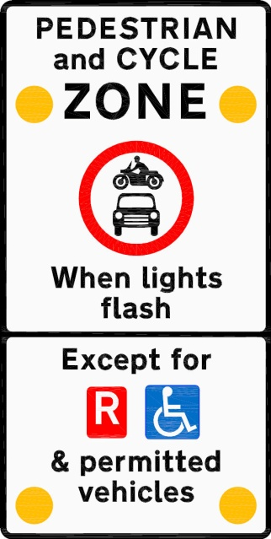

Additional information signage will also be placed within the zone. The ‘R’ symbol represents residents and local businesses, who will receive permits to display in their vehicles when the scheme is operating.

**At what times will they operate?**

The prohibition of vehicles will be for a set period of time; The exact length of the prohibition could vary from school to school, but is likely to be between 30-45 minutes before entry and after exit times of the school. It will only operate during school term times.

**Who will enforce them?**

The scheme can legally only be enforced by Police Scotland; the penalty for ignoring the prohibition is a fine and points on the licence. Diversion routes will also be signed ahead of the school street, giving drivers alternative routes around the closed streets.

**How long will the scheme last?**

It is being promoted by an Experimental Order, so it is only being made for 18 months. Each scheme will then be reviewed and, if deemed successful, can be made permanent by the introduction of a permanent Traffic Regulation Order.

**I am a resident of a school street. Can I drive in and out of my street when the signs are flashing?**

Yes, residents can apply for and display a permit to display in their car, allowing them to drive in and around the school streets. There will be no charge for the permit.

**What other road users are permitted in the street?**

Disabled users displaying a blue badge will be permitted as well as emergency services and contract school transport dropping or picking up pupils from the school. Other groups may also be issued permits depending on information obtained through the consultation.

**Will school staff get a permit?**

No, school staff will not be able to apply for a permit. They must be in the zone before the sign starts flashing.

**This could create congestion on surrounding streets?**

We will be working with school communities to identify and promote locations away from schools where parents can park; this should disperse the cars over a wider area than at present. Reward schemes will be introduced to encourage use of these ‘Park & Stride as well as pedestrian & cycle training, setting up of walking buses (groups of children accompanied by adults), school crossing patrols (at new crossing points) and provision of additional cycle and scooter parking.