|  |  |  |
| --- | --- | --- |
| Residents of Figgate Bank and Street, Whin’s Place, Aithison’s Place, Shrub Mount, Beach Lane and Wilson’s Park | Date | 12 January 2015 |
|  |  |
| Your ref |  |
|  |  |
| Our ref |  |
|  |  |
|  |  |

Dear Residents

**Towerbank Primary School Streets Proposal**

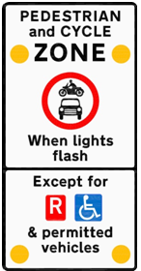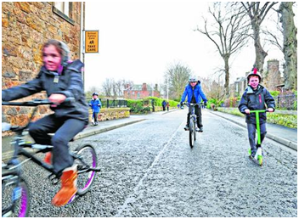

Towerbank is one of 11 primary schools across Edinburgh to have been selected for a School Streets scheme. All locations have been experiencing ongoing road safety issues caused by drivers bringing their vehicles too close to the school gates.

The scheme will prohibit vehicular traffic during specified time periods, before and after school. Free permits will be issued to residents, Blue Badge holders and other permitted vehicles, such as emergency services, exempting them from the prohibition.

An Experimental Traffic Regulation Order (TRO) will be in force for 18 months. At the end of this period, the project will be evaluated and a decision made whether to make the scheme permanent.

Whilst a map of the Towerbank scheme is attached, those of other 10 proposed school street pilots and a list of frequently asked questions are available on the Council’s website at [**https://consultationhub.edinburgh.gov.uk**](https://consultationhub.edinburgh.gov.uk).

**Tell us what you think**

Whatever your views about school streets, as a parent, resident or driver, we want to hear from you. We are particularly keen to get your views on which streets should be included in the pilot project.

A drop-in session has been organised at **Towerbank Primary School** on Wednesday 28 January 2015 between 3pm to 6pm. Council officers will be available at these events to answer questions.

**Public Exhibition**

Maps and information on the proposals will be available from 8 January 2015 at Portobello Library.

Please let us know your views on the pilot school streets proposals. You can send your comments:

**In writing:** Freepost RTCH-JJEK-TCC2, The City of Edinburgh Council, Road Safety, Waverley Court C2, EDINBURGH, EH1 1BR.

**Online:** Go to [**https://consultationhub.edinburgh.gov.uk**](https://consultationhub.edinburgh.gov.uk)and complete the online questionnaire to give us your views.

**Or e-mail:** If you have any questions or would like more information, you can e-mail us at [schoolstreets@edinburgh.gov.uk](mailto:schoolstreets@edinburgh.gov.uk).

All comments must be received by Friday 27 February 2015.

Your comments and suggestions will be considered in detail and findings will be reported to the Council’s Transport and Environment Committee in June 2015.

Yours faithfully

**Caroline Burwell**

**Road Safety Manager**