Portobello
Parking
Survey
Results
(Condensed Summary)

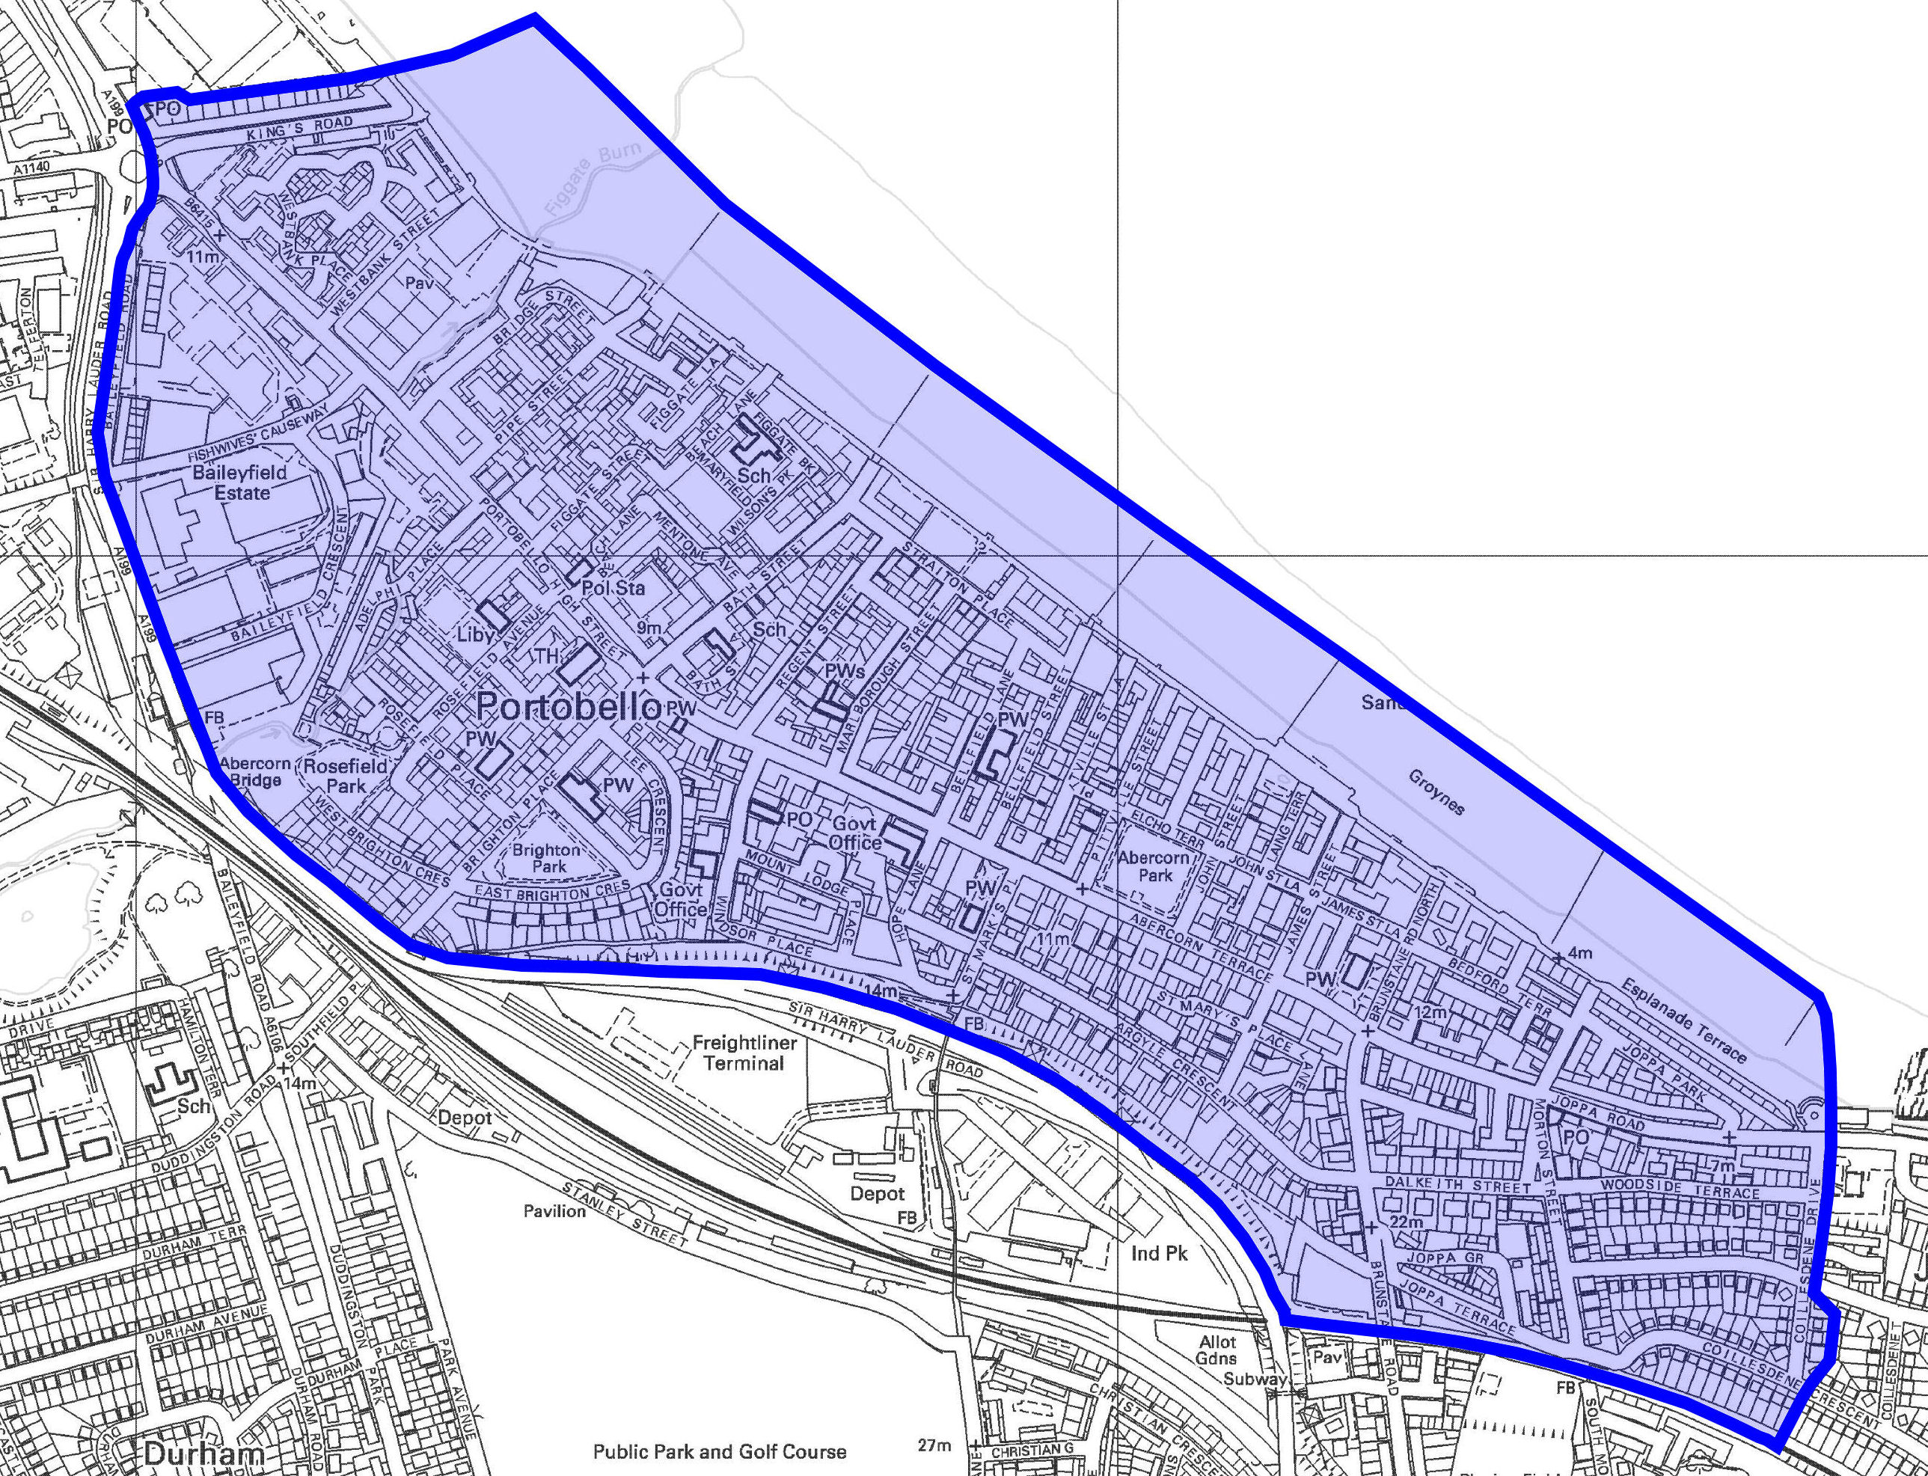

Report October 2014

Introduction

The Portobello parking surveys were conducted over three days in August 2013: Saturday 17 August, Wednesday 21 August and Thursday 22 August.

Headline Figures

This table includes the final figures from the parking surveys

Group | Day 1 (Saturday) | Day 2 (Wednesday) | Day 3 (Thursday) | Overall
Resident | 1849 | 1979 | 2020 | 3821
Resident or Long-stay | 896 | 666 | 697 | 441
Commuter | 165 | 235 | 185 | 250
Short-stay commuter | 108 | 70 | 65 | 146
Visitor | 957 | 1175 | 1007 | 2572
Police | 1 | 1 | 1 | 13
Present | 0 | 0 | 2 | 0
Vehicle Totals | 3976 | 4126 | 3977 | 7243

Key Findings

- The number of residents’ vehicles recorded each day is fairly similar which is within expectations.
- The data indicates that there is not a major commuter parking problem in Portobello as the number of commuters each day is relatively small.
- There are a significant number of visitors to Portobello each day.
- Several streets are operating above capacity. It was confirmed that Marlborough Street and Regent Street, can only accommodate the current number of vehicles due to footway parking on both sides of each road.

Further Analysis

- The initial numbers do not suggest that there is a commuter parking problem in the area. Commuters account for such a small percentage of vehicles surveyed that it is unlikely that anything other than a significant increase would negatively impact on parking pressures.
- While there are many businesses in Portobello, there are very few large employers and it is likely that the main trip generators are the seafront and the local shops and businesses, both being attractive to visitors.
- As anticipated, the number of residents’ vehicles observed starts at a high point and falls during the day before increasing again towards the end of the day. This is shown in two of the three days, with the anomaly of the third day described in the previous section.
- The data suggests that the number of visitors to Portobello is greater than the number of commuters. The peak number of visitors during the day was found to be in the region of 200-250 while the peak number of commuters was in the range of 100-150.
Streets for further investigation:

Table 1 below indicates the streets where the number of residents’ vehicles combined with commuters and visitors result in the street operating above capacity.

There were six streets above capacity on Saturday, five on Wednesday and seven on Thursday.

Table 1: Streets above Capacity
Street | Above Capacity
Street | Saturday | Wednesday | Thursday
Bath Street |  |  | ✓
Lee Crescent | ✓ | ✓ | ✓
Marlborough Street  (Amended Capacity) | ✓ | ✓  ✓ | ✓
Regent Street  (Amended Capacity) | ✓  ✓ | ✓  ✓ | ✓  ✓
Sandford Gardens | ✓ |  | ✓
Straiton Place | ✓ | ✓ | ✓
Windsor Place | ✓ | ✓ | ✓

Introducing controls in a few streets is likely to displace residents’ vehicles to other areas.

There is little excess capacity in Portobello near to the streets which are operating above capacity.

Conclusions

The results of the parking surveys indicate that Portobello is used very much as a local centre, with a significant number of visitors drawn into the area either as a result of Portobello’s seaside status, or simply to visit the many and varied shops, cafes, restaurants and businesses in the town.

Even so, the significant majority of parking that takes place can be traced back to residents themselves. By comparison, visitors and commuters to the area account for a relatively small percentage of the total vehicles parked.

Parking Controls

In terms of what might be considered for Portobello, there are three main options:

- CPZ, where the whole area is controlled with parking places and yellow lines;
- Priority Parking, where only parts of each street might be controlled, primarily with permit holder parking; and
- Limited Waiting, where specific parking places create short term opportunities

Considering the survey results and the potential implications given the parking usage and patterns identified in Portobello, the conclusions must be that:
- that the main source of parking pressure in Portobello is from resident parking;
- parking controls are not needed to remove intrusive commuter parking; and
- the introduction of parking controls would not necessarily help make it easier for residents to find a parking place closer to their homes;
- the introduction of parking controls would not necessarily improve parking availability for visitors;
- that neither CPZ or Priority Parking could provide sufficient benefits to residents, businesses or visitors to warrant their introduction.

Recommendations

To note the results of the parking surveys which suggest that commuter parking is not a significant problem in Portobello and that on that basis the introduction of parking controls is not necessary.

To note that the existing proposal for Limited Waiting in Portobello High Street may provide benefits for visitors and businesses and that further options for similar controls could be investigated, in other parts of Portrobello, to improve parking opportunities for visitors.

