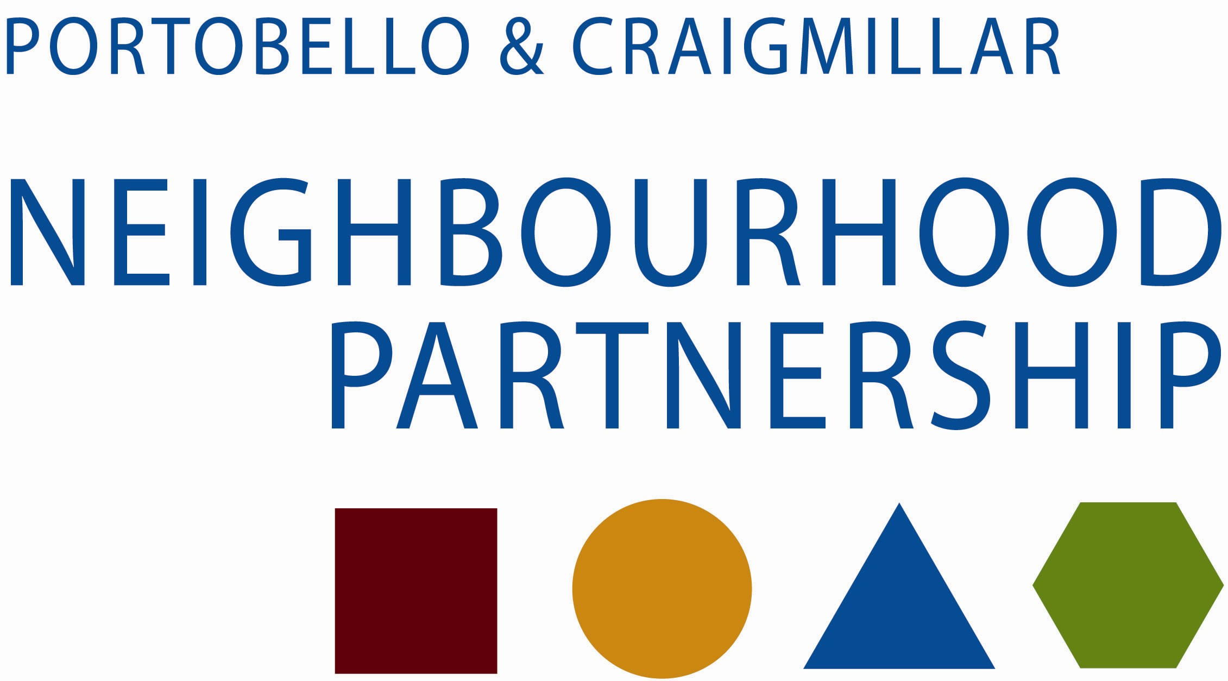
You Decide! 2018
local money for local projects by local people

Privacy Statement – why do we need this information? - You must complete the registration fields so we can check your application meets the funding criteria. We will keep the information that you give us confidentially, only use it for the You Decide PB Initiative and any other potential funding opportunities, and not pass it on to anyone else. Any information that you give us is stored for 2 years and then destroyed. Thank you!

THE INFORMATION ON THIS PAGE WILL BE MADE AVAILABLE TO PUBLIC

Name of your organisation / group

Tell us about your group (what do you do, where do you operate?)

Which funding pot are you applying to?
Small pot (up to £500)
Large pot (up to £1,500)

How much are you applying for?
What would the money be used for (if successful)?

(Please include details like who will benefit, key dates and any estimated costings)

THE INFORMATION ON THIS PAGE WILL NOT BE PUBLICISED.

Contact person:

Address and Postcode:

Telephone numbers:

Email address:

Please give details of your group’s bank account: (account must be in name of group)
Name of bank
Bank address
Account name
Bank sort code
Account number

DECLARATION AND SIGNATURES

All applications must be signed by two people who are recognised as representatives of your organisation.

You are being asked to declare that;

- You will comply with all City of Edinburgh Council funding conditions
- To the best of your knowledge, the information contained in this application and any accompanying attachments is accurate.

Signature………………………………………

Name……………………………………………

Date……………………………………………

Position…………………………………………

Signature………………………………………

Name…………………………………………..

Date……………………………………………

Position…………………………………………

Please return this form to: Partnership Development Officer | Portobello & Craigmillar Neighbourhood Partnership | East Neighbourhood Centre, 101 Niddrie Mains Road, Edinburgh, EH16 4DS.

