DRAFT Minutes of the 37th AGM of Portobello Community Council held on 24th June 2019
Present: Donald Bloxham (acting Treasurer), Lee Kindness (Vice-chair), Esther Gray, Marjorie Thomas, Elaine Murray, Onyema Ibe (taking minutes), Sean Waters, Fraser McNaughton, Justin Kendrick, Catherine Etoe.
Apologies: Madeline Begg, Miranda Hurst (Chair), Cllr Callum Laidlaw.
In Attendance: Cllr Maureen Child, Cllr Mary Campbell, Cllr Kate Campbell and members of the public.

37.1 Chair’s Welcome & apologies
Lee welcomed everyone to the meeting.

37.2 Chair’s report
The annual report was summarised, along with engagement statistics; see Appendix 1 & 2.

37.3 Treasurer’s report
The report was summarised, see Appendix 3.

37.4 Election of office bearers
Cllr Mary Campbell took over chairing of the meeting. A proposal to continue the current office bearers until after the upcoming community council elections was agreed:
Chair: Miranda Hurst
Vice-chair: Lee Kindness
Acting treasurer: Donald Bloxham
Meeting minutes to continue to be taken on a rotating basis until a permanent secretary is appointed.

The 37th AGM was closed.

Appendix 1: Annual report
Portobello Community Council has remained focused on its primary purpose during the period August 2018 to July 2019 which is to consult the residents and business owners it represents and to make their views known to public authorities, service providers and other stakeholders.
To this end, the community council has concentrated on three main objectives:-
- Raise awareness of matters of community interest
- Encourage engagement in community matters by residents, business owners and community groups
- Provide a voice for the community by gathering feedback and making representations (where relevant)
A mixture of online and offline methods have been deployed to achieve these aims.
● The PCC website is updated regularly with public notices, relevant community news as well as formal reports and documentation
● The Facebook page is also regularly updated with public notices and other items of community interest
● The Twitter feed is actively updated and used to share community info
● Regular email newsletters are distributed with information and links
For those who are not online
● The PCC area in Portobello Library is kept up to date
● The noticeboard network is regularly refreshed
● A column is provided for the Porty Reporter
● Consultations at drop-in sessions and public events
Community councillors also liaise with community representatives, the Portobello and Craigmillar Neighbourhood Partnership, local police officers and elected members in helping identify areas of priority or greatest need.
In terms of overall reach, the main headline numbers are as follows:-
Website | 6,200 users
Facebook | 2,412 likes
Twitter | 1,544 Followers
Mailing list | 679 Subscribers
Porty Reporter | Circulation 12,500
Please see separate PCC Engagement report for more detailed statistics

Recent consultations
Portobello Community Council has assisted with or conducted a diverse range of consultations and public information sessions in the last 12 months, including the ongoing proposed sale of the Pitz site on Westbank Street, parking at Kings Place, the development of a skate park at Treverlen Park, the developments at Portobello Sands (Pipe Lane), the replacement of the setts on Brighton Place and a participation request regarding proposals by Edinburgh Leisure to reconfigure the Portobello Golf Course.

Public Notices
The PCC receives a significant volume of public notices from the City Council, Scottish Government agencies and other public bodies. These include Traffic Orders, Licensing Applications, Planning Applications, funding opportunities, consultations on public matters, meeting notices, agenda and reports. As far as possible, these notices are published on the PCC website, Facebook and Twitter feeds so that members of the public can keep up to date.
See http://www.portobellocc.org/pccpn for more details.

Planning
Major planning matters in the period included the proposed sale of the Pitz site on Westbank Street, Brunstane and the Seafield/Local Development Plan.
Relevant planning applications in the area, with public interest are published on the PCC website and can be accessed here:- http://www.portobellocc.org/pccpn/category/publicnotices/planning/

Community-related Initiatives and activities
There are many hundreds of clubs, associations, voluntary groups, charities, businesses and not-for-profit organisations which contribute to the fabric of this community. The community council is just one layer of that, but we have been fortunate to have been given notice of, or been able to contribute to, a wide range of community-related initiatives and activities.
These have included: support for the Beach Wheelchairs at Tumbles, a popular stall at the Portobello Village Show, the annual sandcastle building competition and input into the bouncy castle charity day held by Albert Reid at Straiton Place.

Appendix 2: Engagement statistics
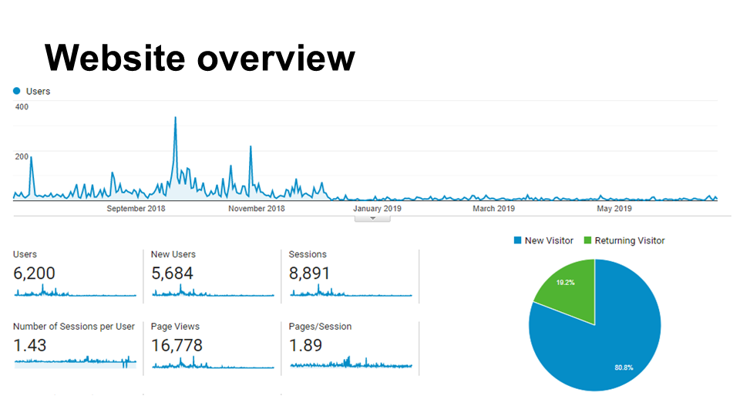
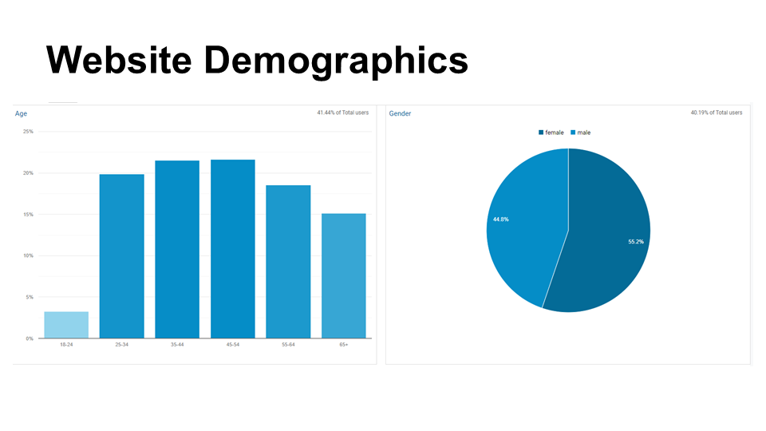
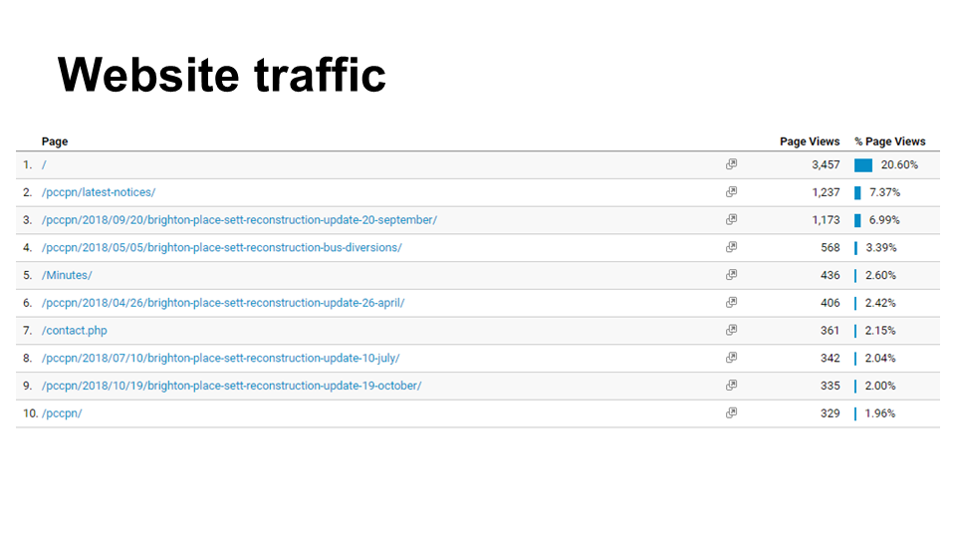
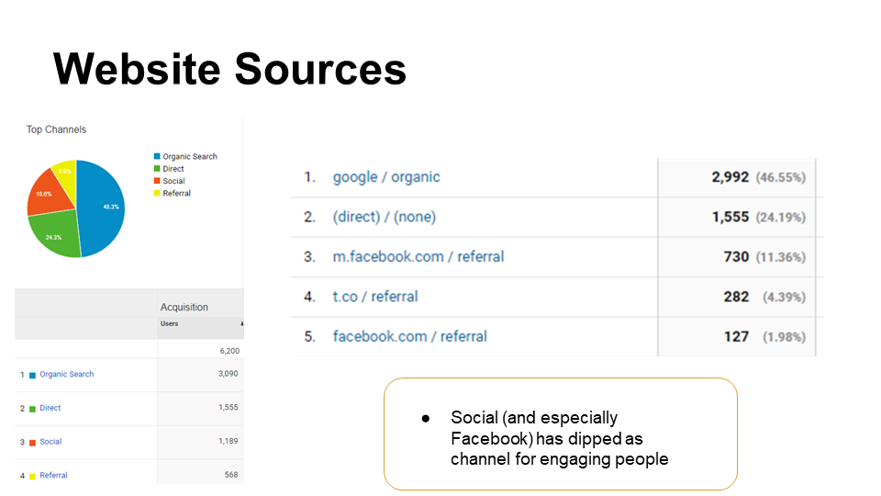
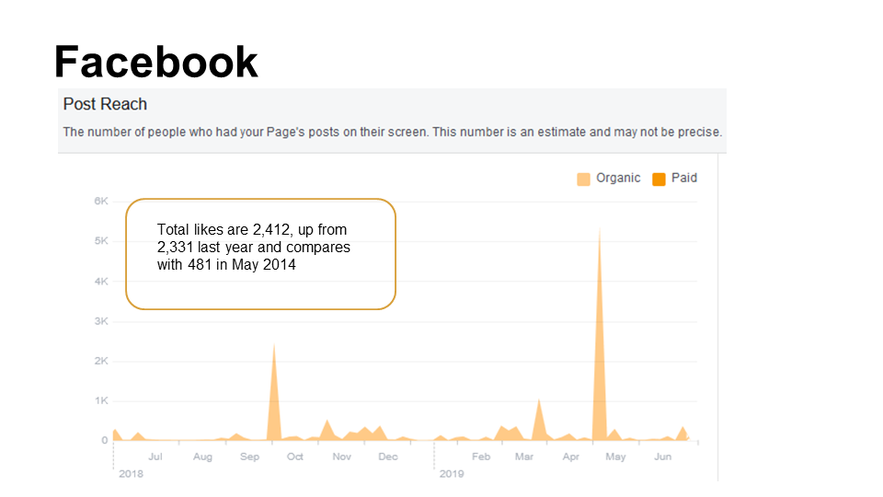
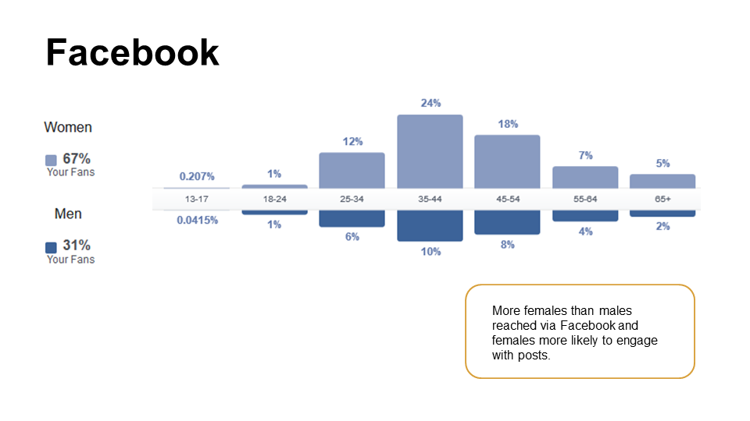
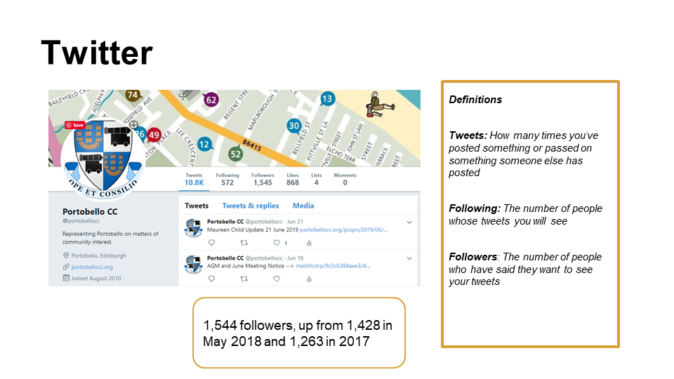
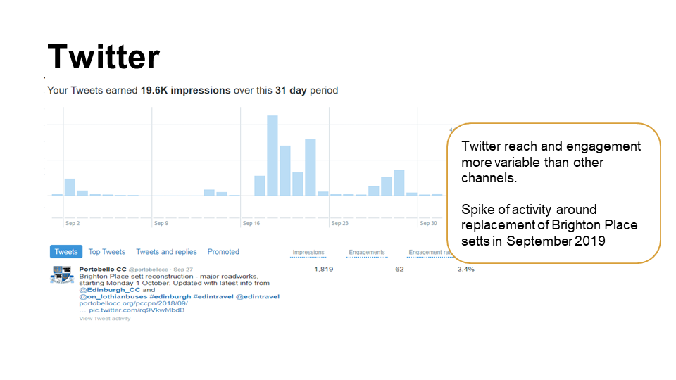

Appendix 3: Treasurer’s report
This statement of account for the year 2018/19 was prepared for the PCC in advance of its August 2018. I will now draw your attention to the main items of income and expenditure for the year.
Donald Bloxham
Temporary Treasurer

Income
The main source of income is the grant of £907 received from The City of Edinburgh Council which is based on ‘a standard lump sum payment plus an additional per capita contribution related to the population for that area’ (Scheme for Community Councils guidance, section 11). In addition, the CEC provided a grant of £500 to cover the costs of upgrading the PCC website, including rendering it mobile-friendly.
Please note that, unlike in previous years, this report will not include reference to any funds held by PCC as donations from local businesspeople for Christmas lights and special events. Those funds cannot be used for the standard business of the PCC. Should anyone require information about those funds, please contact the PCC treasurer.

Expenditure
Major items: In addition to website costs (Typeform cost: £240) and website hosting costs (£113), there were basecamp costs of £240, public liability insurance costs of £250, and rental costs of £400 (though see the next item for further discussion of rent). Please note that a £300 payment for website improvements was made in the following financial year, 2019-2020.

Financial Position
The closing balance (as of 6 April 2019) showed a position of £1871 held as cash in the bank account; the position at the start of the year was £1482. For the financial year 2018-19 PCC income exceeded expenditure by £389. Note, as above, that £300 of relevant expenditure was delayed until 2019-20; on the other hand, as of 2019, the rental costs for PCC meetings diminish significantly (rent is charged by Portobello Baptist Church by calendar year rather than financial year, so the effect of the decrease in rental will be more strongly felt in 2019-2020 than 2018-19).

