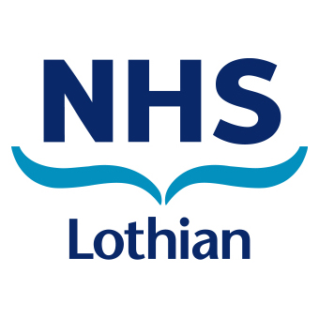
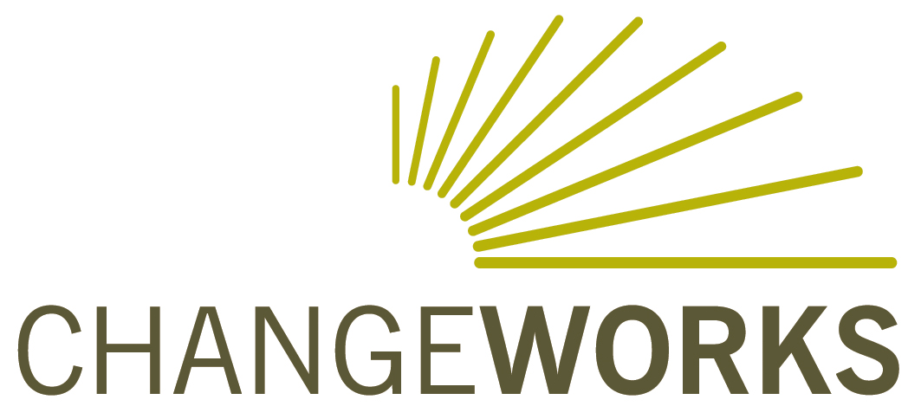

Fuel Poverty and Health Workshop

29 April 2015, 2pm−4pm

Do you deliver face-to-face services in the community, in people's homes, health centres and clinics?

Do you work with people more vulnerable to fuel poverty and those whose health is likely to be made worse by living in a cold, damp home, such as:

- People with respiratory illnesses or Chronic Obstructive Pulmonary Disease (COPD)?
- Older people, disabled people, or those with very young children or who are expecting a baby?
- Anyone experiencing economic hardship?
This free workshop will help participants to identify a fuel poor household, understand the impact on health, and know where and how to refer them on for further help.

For further details and to book a place, please visit www.nhslothianhpstraining.com

This workshop is delivered by environmental charity Changeworks, in partnership with NHS Lothian Health Promotion Service.

