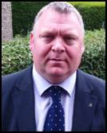

Councillor Mike Bridgman

Portobello/Craigmillar Ward Newsletter

Spring 2015

Welcome to my newsletter.  Please feel free to share the information with anybody you think might be interested, and if you no longer wish to receive my newsletter please email [michael.bridgman@edinburgh.gov.uk](mailto:michael.bridgman@edinburgh.gov.uk) and I’ll remove you from my mailing list.

**Neighbourhood Partnership Update**

Neighbourhood Partnerships bring together the community, Police, Health, Fire, voluntary sector and elected members, supported by officers from the Council.

I convened the last meeting of the **Portobello and Craigmillar Neighbourhood Partnership** on **11 February 2015** at the East Neighbourhood Office and the link below is to the full meeting papers if you would like to see what was discussed.

<http://www.edinburgh.gov.uk/meetings/meeting/3604/portobello_and_craigmillar_neighbourhood_partnership>

If you would like to see the complete Local Community Plan please click the link below.  This is the third plan since Neighbourhood Partnerships were established in 2007.

<http://www.edinburghnp.org.uk/neighbourhood-partnerships/portobello-and-craigmillar/about/portobello-craigmillar-local-community-plan-2014-17-full-version/>

The next Portobello and Craigmillar Neighbourhood Partnership meeting is **13 May** **2015 at 6.30pm** in the East Neighbourhood Office, 101 Niddrie Mains Road.

The upcoming Neighbourhood Partnership sub-group meetings are listed below and if you’d like to get involved or suggest something for the agenda please contact **Graham Rowan** on 0131 529 6374.

P&C Health & Wellbeing sub group - **Tuesday 21 April 2015 at 10.30 am**, venue to be confirmed.

P&C Community Safety sub group - **Wednesday 22 April 2015** **at 2.00 pm**, in the East Neighbourhood Office, 101 Niddrie Mains Road.

**P&C Housing and Regeneration - Tuesday 12 May 2015 at 10.30am at the White House,** 70 Niddrie Mains Road.

P&C Area Board - **Wednesday 3 June 2015 at 5.30 pm** in the East Neighbourhood Office, 101 Niddrie Mains Road.

P&C Environment Forum – **Wednesday 3 June 2015 at 6.30 pm in the East Neighbourhood Office, 101 Niddrie Mains Road**.

**You Decide!**

The **Portobello & Craigmillar Neighbourhood Partnership** decided that applications to its Community Grants Fund in 2015-16 should be decided by the local people.  Applications closed on Thursday 2 April, they will be displayed in Portobello and Craigmillar libraries between 24 April and 5 May, and the **You Decide!** event will take place on Saturday 23 May in the East Neighbourhood Centre.

**“Legal Highs”**

As Convener of the Police and Fire Scrutiny Committee I was invited to attend a seminar which was hosted by Police Scotland and the NHS, and supported by City of Edinburgh Council and the charities Crew and the Angelus Foundation.  The intention of the event was to highlight the dangers of (NPS) New Psychoactive Substances– so called “legal highs”.   S3 and S4 pupils from 20 Edinburgh Secondary schools attended, including pupils from Castlebrae, Portobello and Holyrood.  The young people participated and took on board the serious message which was conveyed.  If the seminar saves one life then it was worth it, and I have to say well done to Police Scotland for organising it.

Below is the link to the article on Police Scotland’s website.

<http://www.scotland.police.uk/whats-happening/news/2015/march/nps-awareness-seminar-for-edinburghs-high-school-pupils>

**Council Tenancies - Kitchen and Bathroom Upgrades**

After visiting constituents in their homes, and listening to their concerns, I have had a meeting with the Housing Convener to discuss progressing the Kitchen and Bathroom programme across the city, but with particular emphasis on areas like Bingham where the properties are 28 years old and have never had upgrades.  The discussions were positive and I hope to have a progress update in the near future.

**Skate Park proposal**

Local parents have contacted me with a request to look at the possibility of having a Skate Park, similar to the successful one at Saughton Park, in our area.  I have had a discussion with the Local Neighbourhood Manager about this piece of unused land in Bingham, and about a proposal that it may be designed as a Skate and BMX Park for local people.  I’ll keep you all updated.

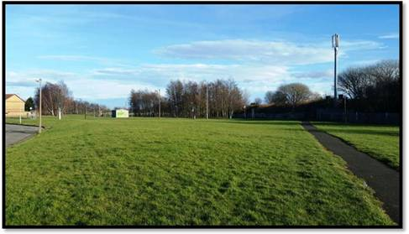

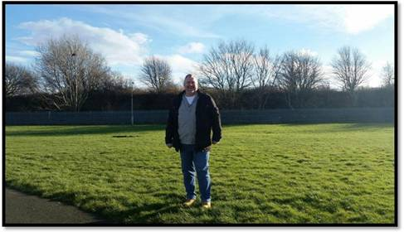

**Community Councils**

**Craigmillar Community Council –** The next meeting is on **Tuesday 14 April 2015** at 7pm in the Hays Business Centre, 4 Hay Avenue. You can come along as a member of the public and voice your opinions or get more involved and become a community council member.

**Portobello Community Council –** The next meeting of Portobello Community Council will take place on **Monday 27 April 2015** at 7:30 pm in Portobello Baptist Church Hall, 185 Portobello High Street.  Meetings are open to the public and all are welcome.

**Local Libraries**

Keep up to date with what events are running at our local libraries on their Facebook pages.

**Craigmillar Library** has a list of School Holiday Activities on their page which include a Treasure Hunt, Crafts and a Trivia Challenge.

<https://www.facebook.com/CraigmillarLibrary>

**Portobello Library -** Their opening hours have recently changed and they can be found on their page –

<https://www.facebook.com/PortobelloLibrary>

**Community Centres**

Our local community centres are also running Easter Holiday activities.

**Bingham Community Centre** has Easter Arts and Crafts on Monday to Friday from April 7 to 17 at 12.30 to 3.30pm.  It’s free for P1 – P7’s but book in advance as places are limited. Call 0131 669 8778

**Magdalene Community Centre** has a programme of events for 4 different age categories.  Contact 0131 669 8760

**Surgeries**

If you’d like to discuss any issues with me in person my surgery times are below.

Bingham Community Complex, 1st Monday 6:00pm (during school term)

Magdalene Community Centre, 1st Monday 7:00pm (during school term)

Portobello Library, 2nd Monday 6:00pm (during school term)

St Francis Primary School, 2nd Monday 7:00pm (during school term)

Outwith those times you can email [michael.bridgman@edinburgh.gov.uk](mailto:michael.bridgman@edinburgh.gov.uk) or call me on 0131 529 4233.  My assistant is Sarah Davidson and her number is 0131 529 4477 or email [sarah.davidson2@edinburgh.gov.uk](mailto:sarah.davidson2@edinburgh.gov.uk)

Best Wishes

Mike