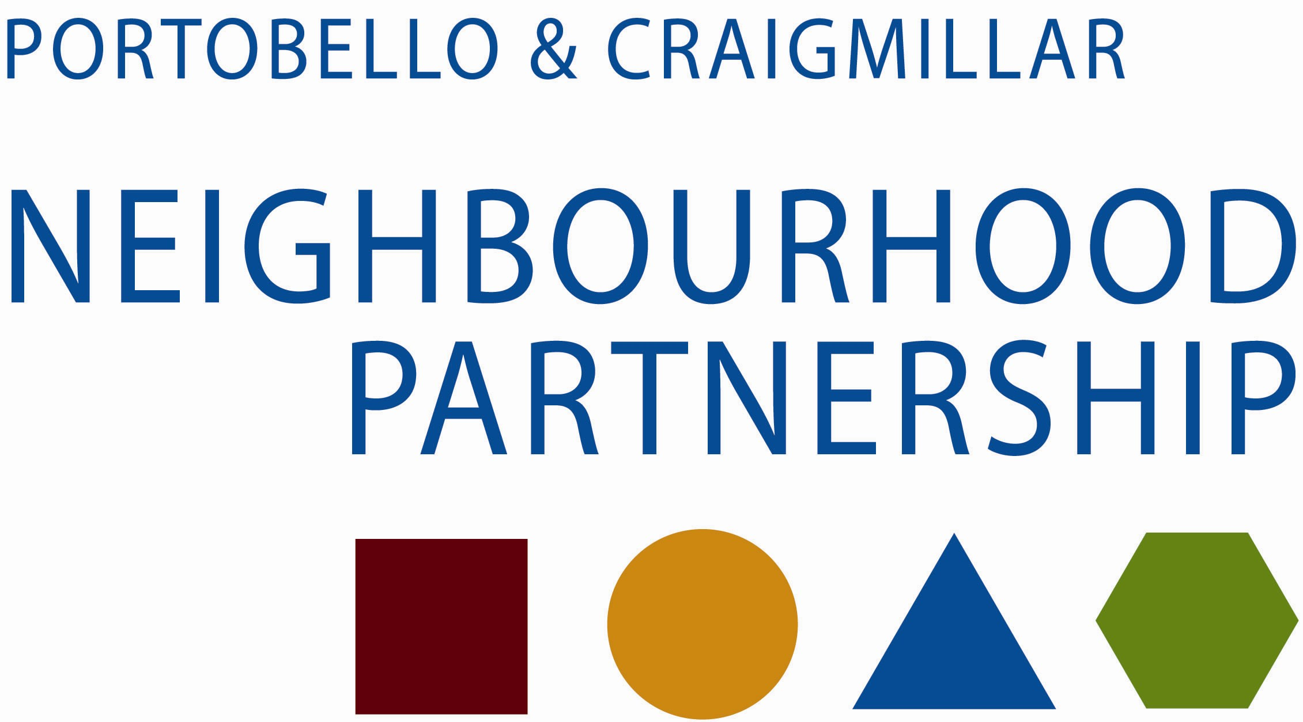

You Decide! 2016
local money for local projects by local people

THE INFORMATION ON THIS PAGE WILL BE MADE AVAILABLE TO PUBLIC

Name of your organisation / group

Tell us about your group (what do you do?) – This information will be publicised.

Describe your project in 30 words (this will be used for publicity)

Tell us about the project you would use the money for.

THE INFORMATION ON THIS PAGE WILL BE MADE AVAILABLE TO PUBLIC

Who will benefit from this project?

Where will the project happen?

Is there a start and end time? (If yes, give dates)  Start……………./ Finish…………….. | How many people in P&C will benefit?

Is your group open to all? If not, please explain.

Is anyone else working with you on the project? If yes, tell us about this.

Do you need any special permission from anyone or insurance to carry out your project? (We may ask you for evidence of this)

Yes No
Give us a breakdown of what each item will cost (for the total cost of the project: |  |  | Have you got any money to put towards the project? If yes, tell us about this.
Item | £ |  | From where | £
Total |  |  | Total

How much money are you applying for from P&C Decides?

THE INFORMATION ON THIS PAGE WILL NOT BE PUBLICISED.

Contact person:

Address and Post Code:

Telephone number:

Email address:

Please give details of your group’s bank account: (account must be in name of group)
Name of bank
Bank address
Account name
Bank sort code
Account number

DECLARATION AND SIGNATURES

All applications must be signed by two people who are recognised as representatives of your organisation. If you have a board/management committee one member of this should sign.

You are being asked to declare that;

- You will comply with all City Of Edinburgh Council funding conditions;
- To the best of your knowledge, the information contained in this application and any accompanying attachments is accurate.

HAVE YOU ENCLOSED?
- A COPY OF YOUR GROUP’S CONSTITUTION.
- QUOTES FOR ANY ITEMS COSTING £200 OR MORE.

Signature………………………………………

Name……………………………………………

Date……………………………………………

Position…………………………………………

Signature………………………………………

Name…………………………………………..

Date……………………………………………

Position…………………………………………

Please return this form to: Graham Rowan | Partnership Development Officer | Portobello & Craigmillar Neighbourhood Partnership | East Neighbourhood Centre, 101 Niddrie Mains Road, Edinburgh, EH16 4DS or graham.rowan@edinburgh.gov.uk .
To be received no later than 22 April 2016.

